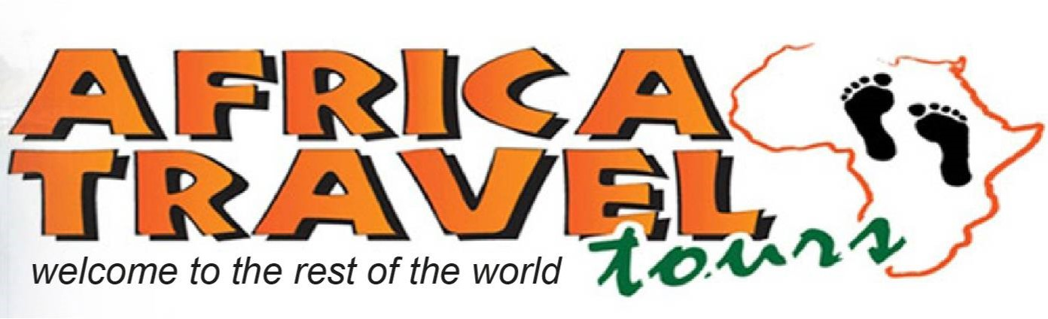
432 Miles Road, Victoria Falls, Zimbabwe, Tel: +263 83 2845017/8, Cell: +263 772 747 993 / 263 712 375 138,
info@africatravelvicfalls.com www.africatravelvicfalls.com

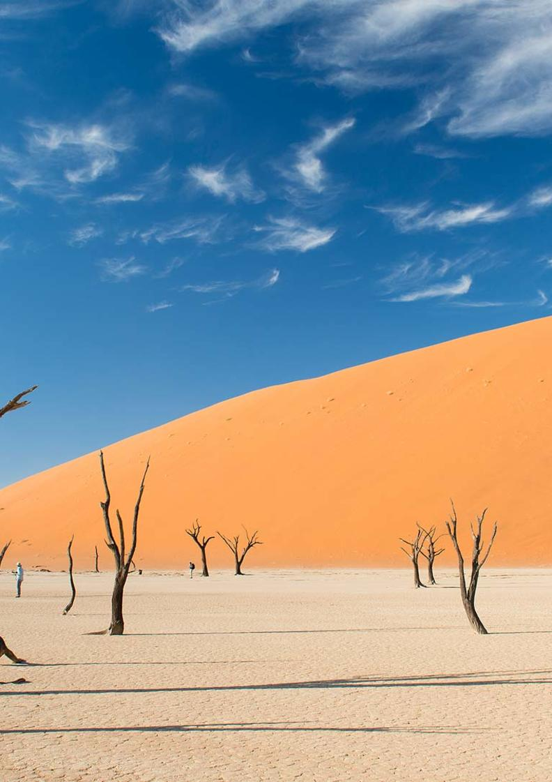

11-Day Namibia Highlights Private Guided Safari - Luxury

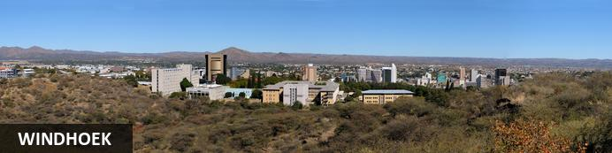
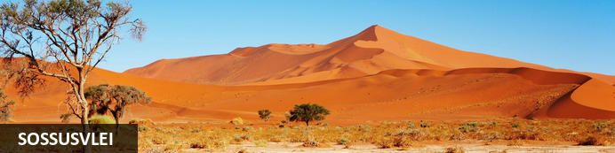
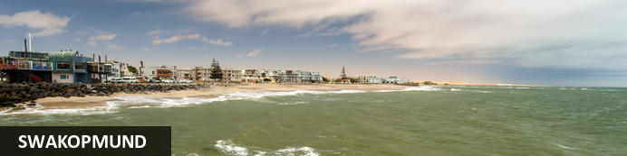
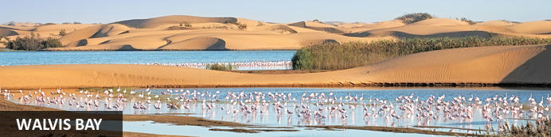
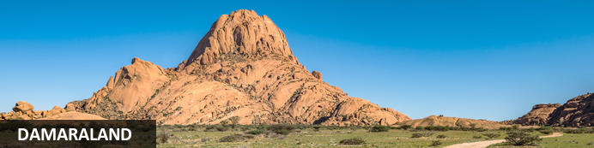
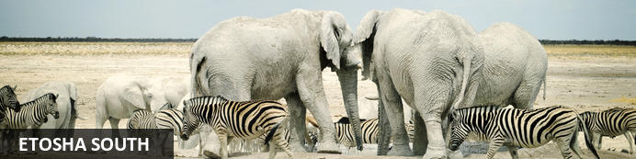
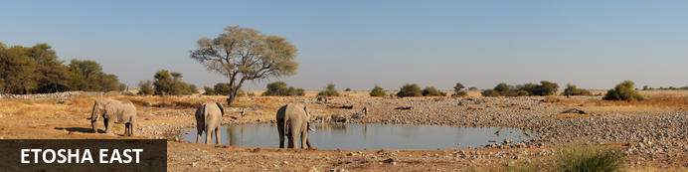

11-Day Namibia Highlights Private Guided Safari - Luxury -
Windhoek - Sossusvlei - Swakopmund - Walvis Bay - Damaraland - Etosha South - Etosha East
11 Days / 10 Nights
Reference: 2024
Date of Issue: 12 September 2023

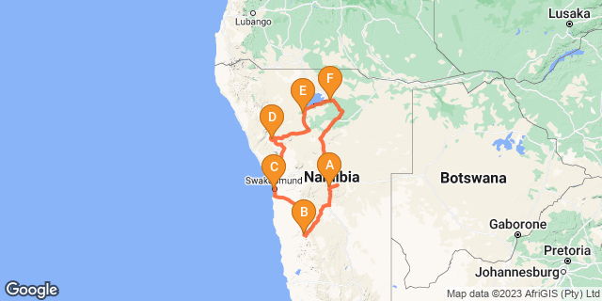

Click here to view your Digital Itinerary

Introduction
You could spend a lifetime exploring Namibia. Here we've assembled the highlights in the 11-day Namibia Highlights Safari – a journey of fascinating discovery that includes the Sossusvlei in the Namib-Naukluft Park, the Skeleton Coast, Damaraland and Etosha National Park.
The Namib Desert covers the entire Namibian coastline of over 1,500km and sweeps up to 200km inland. It is the planet's oldest desert and has an astonishing diversity of landscapes and habitats including the Great Sand Sea of Sossusvlei and the surreal Skeleton Coast north of Swakopmund.
Damaraland's scenic rocky outcrops and sandy riverbeds form a vast undulating landscape that shelters a variety of desert-adapted wildlife including elephant, rhino, lion and some rather hardy plains game.
Etosha National Park’s plains game come to drink during the middle of the day when predators are most lethargic; thus it's not uncommon to have a collage of several different species in the same frame. Lions, elephants and several endemic species of antelope and birds - including 46 raptors - add to the game viewing excitement.

Accommodation | Destination | Basis | Duration
The Weinberg Windhoek | Windhoek | B&B | 1 Night
Namib Outpost | Sossusvlei | D,B&B | 2 Nights
Strand Hotel Swakopmund | Swakopmund | B&B | 2 Nights
Mowani Mountain Camp | Damaraland | D,B&B | 2 Nights
Ongava Lodge | Etosha South | FB | 1 Night
Mushara Outpost | Etosha East | D,B&B | 2 Nights

Key
B&B: Bed and Breakfast
D,B&B: Dinner, Bed and Breakfast
FB: Full Board - Dinner, Bed, Breakfast and Lunch

Price
1st January – 30th June 2024 – Low Season
2 guests – USD 6 380 per person sharing
4 guests – USD 4 810 per person sharing
6 guests – USD 4 256 per person sharing
Single supplement – USD 1 240
1st July – 31st December 2024 – High Season
2 guests – USD 6 560 per person sharing
4 guests – USD 5 430 per person sharing
6 guests – USD 4 820 per person sharing.
Single supplement – USD 1 420

Included
- Accommodation as indicated - can change depending on availability and request at time of booking
- Meals as indicated
- Car hire for 2 & 4 pax - for 6 pax the vehicle is slightly larger
- All vehicle costs including fuel
- All park entry fees
- Guide and guide costs
- Water in the vehicle at all times
- Activities as shown in the itinerary … all activities that can be done with NTS guide and vehicle are included
- Tour file with detailed itinerary, map with route descriptions, vouchers etc.
- 24 hour personal and friendly support
- Fast and efficient response to service providers

Excluded
- Items of a personal nature
- Optional extra activities
- International flights
- Holiday or personal insurance
- Staff gratuities
- Visas and visa applications

Day 1: The Weinberg Windhoek, Windhoek

Windhoek
Surrounded by the stubble-covered Auas Mountains and the endless Khomas Hochland, Windhoek lies in a long valley fed by ancient hot springs in the central highlands. Namibia’s capital and bustling city. More often than not, the start or end place of your
i.
In Windhoek there are many interesting historical buildings, museums, galleries and craft shops. The city has several good restaurants and modern shops and services making it an excellent base camp from which to launch your Namibian adventure.

Day Itinerary
- You will be met by your guide on arrival in Windhoek and handed your travel documents
- City tour of Windhoek (if time permits)
- The remainder of the day can be spent relaxing at your own leisure
- For dinner tonight, you can head into town for a bite to eat at one of Windhoek's well known restaurants

Overnight: The Weinberg Windhoek View iBrochure
If you can imagine yourself in a fine countryside manor house overlooking orchards and then at the same time imagine you are in an urban chic, modern hotel, then you could see yourself at The Weinberg Windhoek for sure. Cape Town meets Stellenbosch in central residential Windhoek.
Previously named, Am Weinberg Boutique Hotel, this elegant 41-room hotel is built around a heritage building. It offers contemporary amenities with a touch of class and sophistication without being presumptuous. While not quite five star, they've perfected the balance between lavish and homely, unpretentious, yet certainly gives you a feeling of being in the presence of the elite.
From colours, textures and materials used, the well thought out décor makes you feel right at home, if the home is that of your wealthy, but down to earth aunt and uncle perhaps. Nothing is out of place and be assured every fine detail has been thought out to ensure a top class stay.
Colonial meets modern, fine country living and 21st century all in one, in harmony. Add great service, multiple dining options, roof–top terrace and world class spa and you find yourself in one of the best up and coming places to stay in Windhoek, without actually feeling as though you are in the capital city at all.
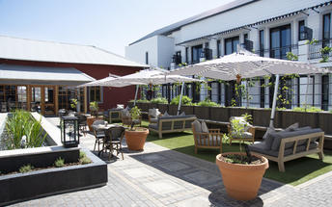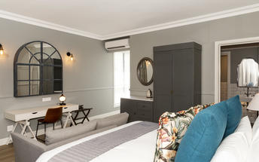

Meet and Greet
NTS Car Hire- Toyota Hilux Safari Private Guided
Toyota Hilux Safari
Travelling as a small group of friends or as a family and need a bit more space than you get with an SUV? Is your focus on photography and you want to get the best shots? This is how you travel in true safari style.

Basis
Bed and Breakfast

Day 2-4: Namib Outpost, Sossusvlei

Sossusvlei
Star dunes with up to five crests rise 300m into the air and rank among the biggest in the world; the dune valleys are marked by vast clay pans where the Tsauchab River gave up its fight to reach the sea more than 60,000 years ago.
Besides the dunes and pans of Sossusvlei and Sesriem Canyon, a sideshow of activities and sights has developed around the region and there are plenty of game lodges that provide additional desert-adapted activities.Plants and birds are the dominant life form in this dessicated realm and they support a tiny world of mammals, reptiles and insects that, in the absence of coastal fog, seldom wander far from the rivercourse and its pans.

Day Itinerary
Windhoek – Sossusvlei 350km - approximately 5 to 6 hours
- After breakfast, you can still pop into town for anything you might need and then depart heading south from Windhoek to your lodge for the next 2 nights
- The route will take you either via the beautiful Spreetshoogte or Remhoogte Pass, both showcasing the natural beauty of Namibia
- Wake up early for breakfast (Day 3) and then head to the entrance to Sossusvlei, the Sesriem Gate
- Spend the whole day in the beautiful Sossusvlei area, exploring the highlights: Sossusvlei, Dead Vlei, Dune 45, Big Daddy, Elim Dune and the Sesriem Canyon
- Return to the lodge for lunch or arrange a lunch pack to enjoy in the dunes and return late afternoon for a well-earned rest
- Optional extra activities: Hot air balloon safari, Nature drives

Overnight: Namib Outpost View iBrochure
Namib Outpost, once Desert Homestead Outpost, is an upmarket, upscale, up-everything version of the Desert Homestead Lodge in the Namib Desert 30km from the entrance to Sossusvlei.
The main lodge appears to be have been carved out of the desert rather than built atop it so natural are the materials and so sensitive the architecture. At the base of a rocky mountain, Namib Outpost looks out across what must be one of the most spellbinding views on Earth: an uninterrupted panorama so vast it beggars belief, no hint of human habitation and an ever-shifting spectrum of blondes, browns, yellows and reds framed by a mountain range of Marsian hues topped with a deep blue sky only the world’s oldest desert can produce. Words are an insult; we suggest you witness it yourself.
Twelve huge stone-walled, thatch-roofed, canvas-sided suites line the mountain base, spaced far apart and angled just right for you to enjoy the view as if it were yours and yours alone through the floor-to-ceiling windows or your shaded balcony. The décor is understated and elegant, the en suite bathroom is huge with a double-volume shower and twin basins. An outside stairway leads you to a flat-topped portion of roof where you can watch the night sky - with zero light pollution - doing its level best to top the daytime viewing.
The main lodge serves a set menu dinner under those same stars, or indoors beside a towering chiminea on wintry desert nights. A swimming pool, bar, viewing deck and cool lounge cover all the de-stressing bases. Perhaps the most amazing feature of this wonderful desert outpost is the solar power. Topped with panels the shaded carports form a rather sizeable solar farm that powers your air con, charges your gadgets, and cools your drinks; even your hot water is solar heated.
Despite the arid conditions, you will likely see oryx - the national animal of Namibia - ostrich, mountain zebra and springbok dotting the plains below. Keep a pair of binoculars at hand and you might be lucky enough to see cheetah or leopard - a good excuse for another cold drink thank you very much. High above the lodge is an unmissable sunset viewing deck and the Outpost has a well-marked 10km running trail for the mentally unstable (although even the most lethargic among us might be tempted to experience a car-free trundle through this haunting landscape). Another activity you should seriously consider is an overnight hike between the Desert Homestead and the Outpost - in that order we suggest. The hike is fully portered and doesn’t require extraordinary levels of fitness. And of course the Desert Homestead is most famous for its desert rides either short outrides or multi-day treks - could there be a better way to experience this magnificent place? A hot-air balloon at sunrise might come close. And did we mention a day trip to Sossusvlei? Don’t forget about Sossusvlei.
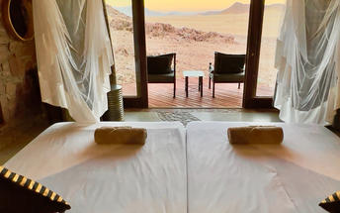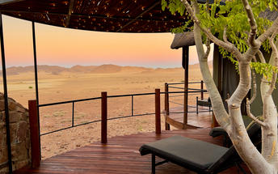

Basis
Dinner, Bed and Breakfast

Day 4-6: Strand Hotel Swakopmund, Swakopmund

Swakopmund
Surrounded by the ancient Namib desert and the inhospitable - but bounteous - Atlantic Ocean, Swakopmund is alive with activity and has a lot on offer for the adventure-seeker: quad-biking, sand-boarding, horse-riding, skydiving and more.
Swakopmund has many interesting German-influenced buildings from the early 1900s in a variety of styles and, for its size, Swakopmund has an astonishing array of restaurants that serve mainly seafood, steak and many German staples.

Walvis Bay
Walvis Bay is an industrial port which lies along the Atlantic Ocean, off Namibia's Skeleton Coast. The large bay and surrounding sand dunes help make Walvis Bay a tourist mecca with loads of activities on offer to explore it.
- Explore the Skeleton Coast where the dunes meet the sea at Sandwich Harbour‍
- Go on a dolphin boat cruise in the harbour. Enjoy champagne and oysters
- Kayak among the seals at Pelican Point
- Visit and climb the mighty Dune 7‍
- Visit the RAMSAR wetland birding site and the Walvis Bay Lagoon. Thousands of flamingos from October to April‍
- Explore the neighbouring town of Swakopmund. Activities abound and dining delights

Day Itinerary
Sossusvlei - Swakopmund 350km - approximately 5 to 6 hours
- Depart after breakfast and head north to Solitaire, then west crossing the Tropic of Capricorn, through the Gaub and Kuiseb Canyons via the Namib Gravel Plains to the coast
- Either via Walvis Bay to Swakopmund, or (recommended) detour via Ganab to the Welwitschia Plains and Moon Landscape
- The Namibian coastline is generally known as The Skeleton Coast due to the barren areas, shipwrecks and, in days gone by, whale skeletons left on the beach
- 1 full day is set aside for this lovely area where Swakopmund and Walvis Bay offer a wide range of activities such as: Dolphin cruise, Sandwich Harbour excursion (a real Skeleton Coast experience), Dune quad biking, Sand boarding, Sea kayaking, Lots more…
- Lunches and dinners can be enjoyed at a cafe or restaurant overlooking the sea

Overnight: Strand Hotel Swakopmund View iBrochure
Occupying most of the breakwater responsible for the calm bay, the Strand Hotel is inches from the roaring Atlantic. Rooms, spotless and tasteful, come in a variety of sizes and configurations, most of them sea-facing, and are equipped with the modern hotel's in-house conveniences like wi-fi, flat-screen telly, international plug points, air conditioning and, to be on the safe side you've got a mini-bar and room service. You get the impression they really want you to eat, drink and sleep well at the Strand Hotel. And so you shall.
The Strand includes three dining options not to mention room service.
The Brewer & Butcher is clearly building on the Brauhaus and Kucki's success stories. A lively place to enjoy traditional Namibian food which is, by turn, influenced by German food so expect jolly portions of Eisbein sidestepping trays of cascading bierkröge held aloft. The Farmhouse Deli is where the buffet breakfast is served offers a more informal cafe feel. The Ocean Cellar is The Strand's signature restaurant and presents an exciting and much-needed quality seafood restaurant to balance out Swakopmund's meat-heavy palate. The sushi is excellent as are the oysters and, like all the eating options, you can see, hear, smell and even taste the sea. Or you can turn and face the show kitchen and enjoy that oh-so-soothing experience of watching a team of experts at work.
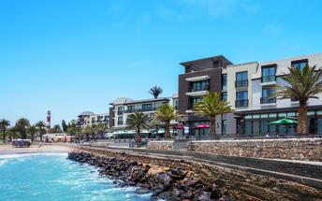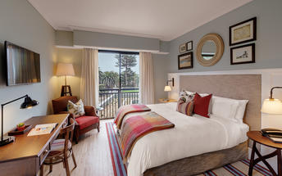

Basis
Bed and Breakfast

Day 6-8: Mowani Mountain Camp, Damaraland

Damaraland
Damaraland features vast khaki plains, sheer rocky mountains and incredible desert-adapted wildlife. Track rhino and desert elephant, explore the rugged land or sit back and enjoy the dramatic and endless scenery. Damaraland's hilly savannah supports a large number of species including lion, leopard, cheetah, hyena, eland, kudu, giraffe, klipspringer, steenbok, gemsbok and springbok. Birdlife is prolific with over 33 raptors recorded including cuckoo hawks, Egyptian vultures and peregrine falcons - the world's fastest animal.
Damaraland is divided into several enormous private game reserves, known as concessions, that support most species of Namibia's large game and provide some of the best birding and wildlife experiences in the country - and southern Africa for that matter.

Day Itinerary
Swakopmund – Damaraland 445km - approximately 7 to 8 hours
- Head north along the Skeleton Coast, via Henties Bay to visit the Cape Cross seal colony. Along the way, stop at the Lichen Fields as well as the ship wreck between the colourful small town of Wlotskasbaken and Henties Bay
- Backtrack to Henties Bay and head inland through wide open plains to Uis, then north to the Twyfelfontein area
- Visit to Namibia's Open Air Museum, the Twyfelfontein Rock Engravings as well as the interesting Organ Pipes rock formations and Burnt Mountain
- Take a drive with your guide, west (4x4 needed) to the Huab River to look for the desert adapted elephants as well as other game such as oryx, springbok, ostrich and lots more
- Visit the Damara Living Museum for a hint of culture

Overnight: Mowani Mountain Camp View iBrochure
Mowani Mountain Camp offers luxury accommodation, a relaxed atmosphere and what could be one of the best views in Namibia. The vast landscape of true Damaraland as far as the eye can see.
Just short of 20 kilometres from the sights that make the area of Twyfelfontein famous, on an outcrop, above the desert landscape below, you'll find Mowani Mountain Camp built on wooden platforms, hidden amongst granite boulders.
The camp's 12 tented rooms (4 Superior View, 3 View and 5 Standard), are fit for a queen with plush beds, luxurious en suite bathrooms with an exhilarating roofless section, and a private balcony with superb views of the Abu Huab River valley and Damaraland all around. If you're upping the ante and staying in the Luxury Room, Mini Suite or Mountain Suite, enjoy that view from your very own splash pool.
A refined mix of luxury and comfort, chic modern accents with touches of Africa and a stillness that brings inner peace. The perfect place to unwind and take in all the "nothingness" that surrounds you.
The private suite stops at nothing in the luxury department with a sublime setting high on a granite outcrop. A private butler will tend to your every need and the lounge, bedroom and open-air bathroom all share the same fantastic view.
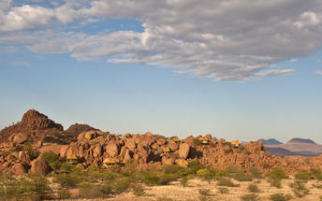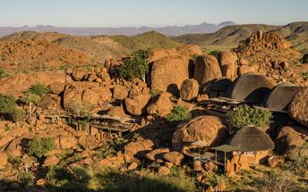

Basis
Dinner, Bed and Breakfast

Day 8: Ongava Lodge, Etosha South

Etosha South
Located just south of the boundary of Etosha National Park in northwestern Namibia, Etosha South makes up the southern region of this wild paradise. The area is comprised of a collection of world class private game reserves. The national park can be accessed via the southern entrance at Andersson’s Gate. Visitors can catch a glimpse of a variety of wildlife including: lion, giraffe, elephant, white and black rhino, and a multitude of plains game. Popular activities include: enjoying an open 4x4 safari with an expert guide, half day or full day drives with the option of a picnic lunch with wine on the full day game drive.

Day Itinerary
Damaraland – Etosha (south) 325km - approximately 4 to 5 hours
- After breakfast, drive east towards Khorixas stopping at the Petrified Forest en-route
- From Khorixas head further east along the tar road to Outjo and then north to your lodge which is situated very close to the southern entrance of Etosha, the Anderson Gate
- If time permits, enter Etosha for an afternoon game drive. Depending on how often you stop today, you should arrive at your lodge in time for lunch (optional extra)
- On entering the park, the first stop would be Okaukuejo where you pay your entry fee (included) and I suggest you pop in at the local shop to purchase some drinks and snacks and most importantly, a map of Etosha which will show you all the waterholes along the way
- Etosha is one of Africa's great game parks. With 114 species of mammal and 340 species of birds you are sure to see a great variety of wildlife on your safari

Overnight: Ongava Lodge View iBrochure
Ongava Game Lodge has a rustic overcoat that fails to conceal its underbelly of luxury and elegance. The 14 enormous thatched chalets each have an en suite bathroom - with a view - and a large verandah looking out over the reserve.
You are perched on top of a hill here, so the views out from the main deck are well grand but this also means it's a trundle down to your room and back up again. The main lodge is open-sided under a canopy of timber and thatch and has a split-level living area, a dining room and a bar. The swimming pool looks out over a floodlit waterhole. There's a hide at the waterhole too. Splendid.
Ongava is a 30,000ha private game reserve on the southern edge of Etosha. There are three other lodges in the reserve - Little Ongava Lodge and Anderssons @ Ongava, for complete luxury and Ongava Tented Camp for an elegant sufficiency. The reserve has all of Namibia's wildlife and is the biggest custodian of black rhinos in Namibia. A highlight of the private reserve is a walking safari in which you track both black and white rhino or you can do white rhino approaching- with an armed ranger of course.
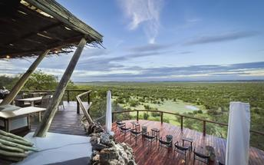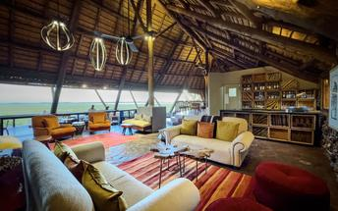

Basis
Full Board - Dinner, Bed, Breakfast and Lunch

Day 9-11: Mushara Outpost, Etosha East

Etosha East
On the eastern edge of Etosha National Park, the park itself is bordered by numerous private reserves and access into the park is via the Von Lindequist Gate, named after Dr. Friedrich von Lindequist who proclaimed it a game reserve in March 1907. This side of the park is characterised by flat endless plains, tree-savanna type of vegetation and fantastic waterholes, where you could easily spot any of the prolific wildlife Etosha is known for. There's an abundance of wildlife here.

Day Itinerary
Etosha (south) – Etosha (east) a full days game drive through the park
- From one side to the other side of the park is a full day game drive as you drive slowly east stopping at numerous waterholes along the way
- Take a slow drive in the morning and ending for lunch at the Halali Resort which is half way between Okaukuejo and the eastern exit gate or take a picnic lunch along and stop off at a waterhole
- 1 full day is set aside for game viewing, either all day or alternate with morning and afternoon guided drives

Overnight: Mushara Outpost View iBrochure
Sophisticated and elegant, Mushara Outpost is a luxury addition to the Mushara collection of lodges on the eastern side of Etosha National Park.
Accommodation at Mushara Outpost is paired down luxury with eight chalets built on elevated decks with canvas roofing, floor-to-ceiling glass doors, en suite bathrooms with enclosed toilet and an open-plan shower with a cheeky private view of the Namibian bush.
The main living area is a charming farmstead house with a massive wrap-around verandah providing cool shade from the blazing sun and cooling the airy interior even further.
A large swimming pool invites an afternoon doze and the evening campfire, wine cellar and fancy food complete the picture of delightful relaxation.
The lodge is in a private game reserve with several small antelope and hundreds of birds setting the stage for your safari proper into Etosha, which is just 10km from your piece of paradise.
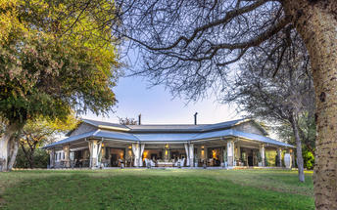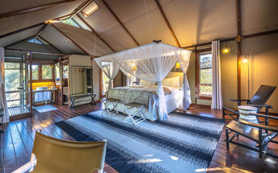

Basis
Dinner, Bed and Breakfast

Day 11: End of Itinerary

Day Itinerary
Etosha (east) – Windhoek 490km - approximately 6 hours
- Head back to Windhoek today, where your guide will drop you at the airport in time for your departure flight (Keep in mind that you need to be at the airport 2 hours prior and the airport is still a 45 minute to 1 hour drive from town)
- End of services

Basis
Bed and Breakfast

Transport

Transfers
Date | Company | Pick Up | Drop Off | Time | Vehicle
 |  | Hosea Kutako International Airport [WDH] | The Weinberg Windhoek |  | Fully Guided Trip
 |  | The Weinberg Windhoek | Namib Outpost |  | Fully Guided Trip
 |  | Namib Outpost | Strand Hotel Swakopmund |  | Fully Guided Trip
 |  | Strand Hotel Swakopmund | Mowani Mountain Camp |  | Fully Guided Trip
 |  | Mowani Mountain Camp | Ongava Lodge |  | Fully Guided Trip
 |  | Ongava Lodge | Mushara Outpost |  | Fully Guided Trip
 |  | Mushara Outpost | Hosea Kutako International Airport [WDH] |  | Fully Guided Trip

Terms and Conditions

Africa Travel Tours Terms and Conditions
Contract
1.1 The contract will become effective as from the date the invoice is completed and the deposit, referred to in Clause 2.1, is received by Africa Tours & Safaris CC (hereinafter known as the Company).
1.2 The contract is subject to the Namibian Law.
1.3 Any person making a reservation as per Clause 8.4 accepts the terms and conditions of this agreement set out hereunder.
How to Book
2.1 A 20% deposit of the full amount due is required to confirm any reservation and is to be done by the agent or client (see Clause 8.1) in writing or by e-mail.
2.2 The Company must receive the balance of the contract price no later than 42 days (6 weeks) prior to departure.
2.3 If the Company does not receive the full contract price 42 days (6 weeks) before the departure date, the Company may cancel the reservation and retain whatever deposit or other funds it has already received from the client or his agent.
How to Pay
3 The payment options will be provided upon confirmation of a booking.
Our Cancellation Policy
4.1 Any cancellation of a confirmed booking must be done in writing (email) to the Company whereupon cancellation charges as per Clause 4.2 will apply.
4.2 The following cancellation fees (as a percentage of the fully quoted price) are applicable to any cancelled travel:
Notice from date of travel: Cancellation fee:
42 days or more 20% (deposit forfeited)
29 – 41 days 50%
15 – 28 days 75%
0 – 14 days 100%
Please note: the notice period is calculated from the date of cancellation to the start date of the tour/safari booking.
4.3 No refund will be made by the Company if, for any reason, inclusions or parts of the tour cannot be carried out / or utilised. These would include all facets such as meals, game drives, accommodation etc. This would also apply to any client who has booked a tour but fails to undertake the tour for any reason.
Our Changes Policy
5 If a booking is changed to an earlier date than originally reserved, the Company will endeavour to change it. If the booking is for a later date, charges as per Clause 4.2 could apply.
As things go, we've all had to adapt to changes during the Coronavirus pandemic and so too have we therefore amended our terms and conditions for travel during such times. Check out the Updated COVID Terms and Conditions here.
Price Changes
6.1 The Company reserves the right to increase the price of any tour prior to departure due to factors beyond the control of the Company, such as, without being limited to, and increase in fuel prices, new Government legislation, accommodation price increases, fluctuations in exchange rates, etc.
6.2 If the Company announces an in increase in the tour price in terms of this Clause, such addition amount must be paid to the Company before the departure of such tour or else the Company shall have the right to cancel the tour and the charges in Clause 4.2 will apply.
Changes to Itineraries
7 The Company shall at any time have the right, in its entire discretion, to alter the terms of the booking in relation to the route, timetable, itinerary and accommodation. The Company shall, however, make every effort to offer the client an alternative tour of a comparable standard.
Should the alternative be of a lesser standard, the client will be refunded the difference, but should there be an increase, the client shall have the right to either reject the alternative and obtain a refund of the relevant portion of the original contract sum, or to accept the alternative and pay the increased cost. In the event of the client rejecting the alternative tour and claiming a refund, such rejection will be treated as a cancellation and the refund will be calculated according to Clause 4.2 hereof. The client shall have no claim against the Company for any damages arising out of the alternative booking.
Responsibility and Liability
8.1 Neither the Company nor any person acting for through and on behalf of the Company shall be liable for any loss or damage whatsoever arising from any cause whatsoever and without restricting the generality of the aforegoing shall particularly not be responsible for the loss or damage arising from any errors or omissions contained in its brochure or other literature, late or non-confirmation or acceptance or bookings, loss or damage caused by delays, sickness, injury or death, whether occasioned by negligence or not.
8.2 The Company shall have the right at any time at is sole discretion, to cancel or the remainder thereof or to make an alteration in the route, accommodation price or other details. This would include any event of any tour being rendered impossible, illegal or inadvisable by weather, avalanches, strike, war, government or other interference or due to any other cause whatsoever. The extra expenses incurred as a result thereof shall be the responsibility of the client.
8.3 The Company may at its discretion and without liability or cost to itself at any time cancel, or terminate, a client's booking and in particular, without limiting the generality of the aforegoing, it shall be entitled to do so in the event of illness or the illegal or incompatible behaviour of any client undertaking the tour, who shall in such circumstances not be entitled to any refund.
8.4 Any person making a reservation with the Company (refer to Clause 1.1) warrants that her or she has the necessary authority to enter into this contract on behalf of the person or persons included in such a booking. The person making the reservation shall be liable for the total amount due to the Company.
Client's Obligations
9.1 It is the onus and responsibility of the client to obtain the necessary comprehensive insurance before departure for any possible cancellations, medical expenses, protection or personal property and money.
9.2 The onus is upon the client to ensure that passports and visas are valid for the duration of the safari. The Company cannot be held liable for any necessary visas or other travel documents not held by clients. In the event of a client not having the necessary documentation to enter any area or country the Company shall reserve the right to leave the client a the point of entry of such area or country. In such an event, the Company will not be held responsible to the client for further travel arrangements.
9.3 The onus is upon the client to ensure that the SARS-CoV-2 PCR tests are done prior to commencement of the safari and valid on arrival in accordance to the requirements of the country of intended travel and for the airline with which the client will travel. The same applies for any necessary testing for departure. The costs of any such COVID testing will be for the clients own account. While The Company can assist with arrangements for testing in-country, The Company will not be held responsible to the client for such arrangements and with regards to return time of test results.
9.4 Should the client need to undergo mandatory quarantine once in-country with regards to the SARS-CoV-2 virus, either on arrival as called for by the authorities or due to testing positive once in-country, this will be at the clients own expense.
Health and Personal Safety
10.1 The client shall be reasonably fit to undertake the tour.
10.2 Anti-malaria precautions should be commenced prior to tour departure. A medical doctor should be consulted for advice.
10.3 Tours offered by the Company cover a wide spectrum of the African wilds and neither the Company, its employees or agents can be held responsible for any injury or other related incidents whilst on the tour / safari.
10.4 The Company cannot be held responsible for any client who falls ill or contracts the SARS-CoV-2 virus while in-country. The client accepts that travel is at own risk.
Baggage
11.1 Clients are limited to one soft sports type bag per person with a maximum weight of 20 kilograms. This includes photographic equipment and hand luggage.
11.2 Due to the rugged terrain, the Company cannot be held responsible for damage or loss of any personal items including bags, contents of bags or photographic and related equipment. Due to extremely dusty conditions, please ensure all bags are dust proof.
Airline and Car Hire Clause
12.1 The Company will act as the agent of the client when booking the client with a car hire company, an airline or air charter service. The client therefore contracts with the car hire company, airline or charter service and not with the Company.
12.2 Charter flights are normally operated by smaller type aircraft such as Cessna 210. Luggage is strictly limited to 10-15 kgs (depending on terms of particular airline used) per person in soft hold all type bags. Due to the desert heat, it is not safe to overload aircraft thus this limit needs to be strictly controlled.
Travelling or thinking of travelling during the COVID-19 pandemic? Take a look at our COVID Terms and Conditions for more information on how this will work and differ from our standard terms and conditions as listed above.

