432 Miles Road, Victoria Falls, Zimbabwe, Tel: +263 83 2845017/8, Cell: +263 772 747 993 / 263 712 375 138, info@africatravelvicfalls.com www.africatravelvicfalls.com

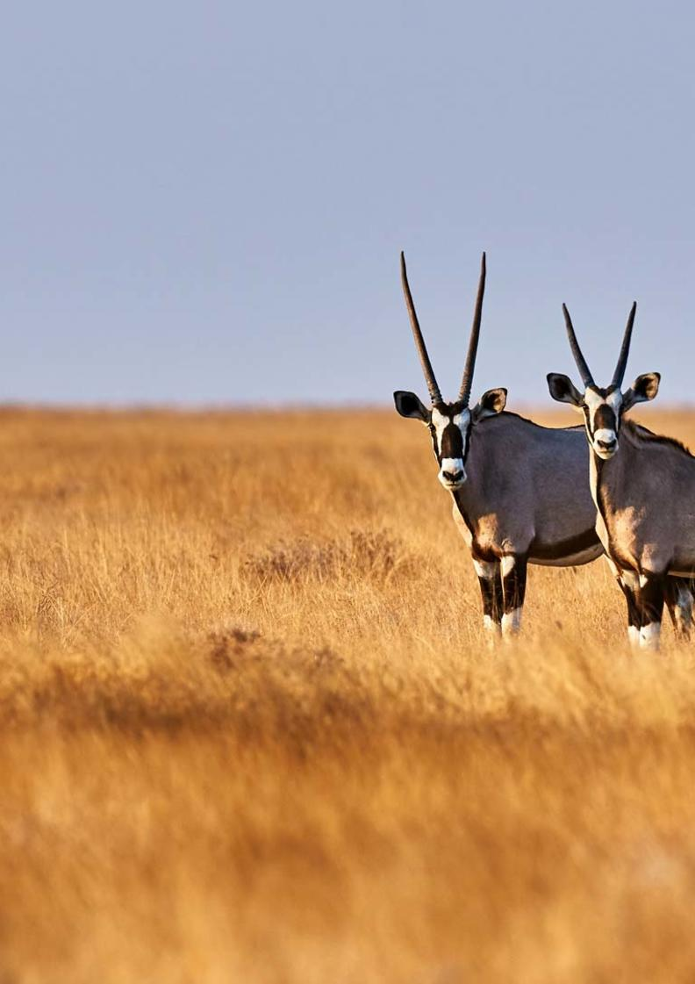
19-Day Ultimate Namibia Self-drive Safari - Standard -

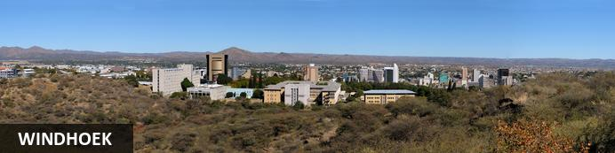
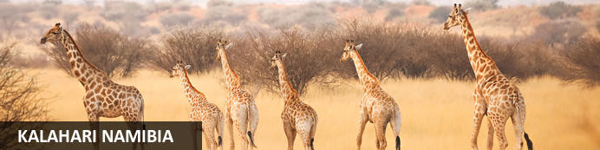
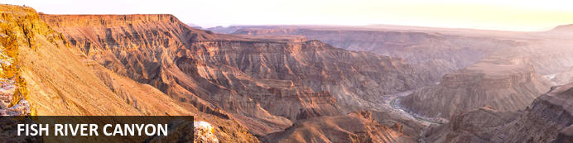
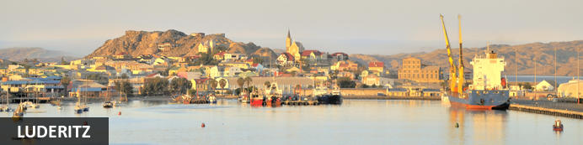
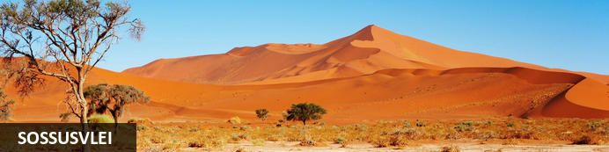
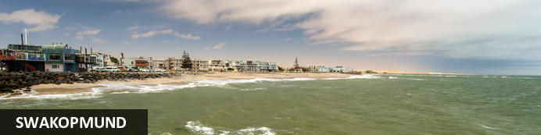
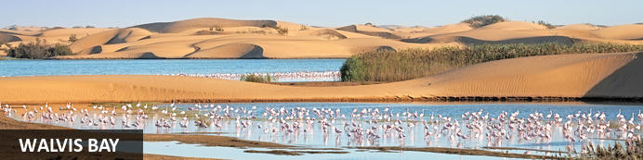
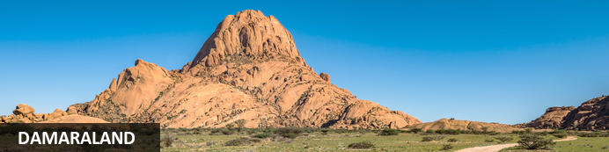
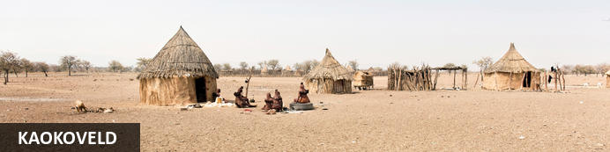
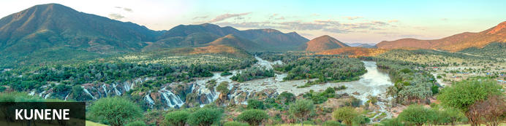
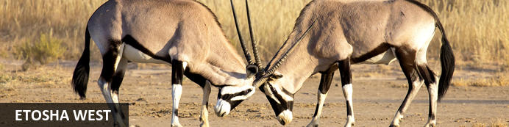
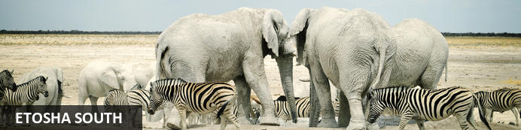
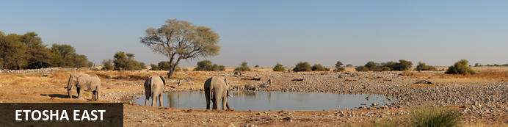
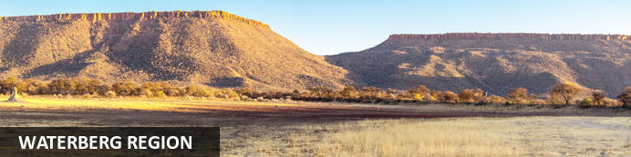

19-Day Ultimate Namibia Self-drive Safari - Standard - NETT
Windhoek - Kalahari Namibia - Fish River Canyon - Luderitz - Sossusvlei - Swakopmund - Walvis Bay - Damaraland - Kaokoveld - Kunene - Etosha West - Etosha South - Etosha East - Waterberg Region
19 Days / 18 Nights
Reference: 2024
Date of Issue: 12 September 2023

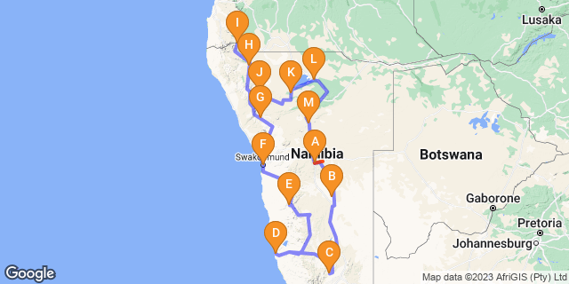

Click here to view your Digital Itinerary

Introduction
The best of Namibia in a 19-Day Ultimate Namibia Safari starting and ending in Windhoek that includes the highlights of Namibia: The Kalahari; Fish River Canyon; Lüderitz; Sossusvlei, with its great sand sea; the seaside towns of Swakopmund and the Skeleton Coast; Damaraland, with its fascinating rock formations, Bushman rock art and desert-adapted wildlife; Kaokoland, the last frontier of true wilderness and the realm of the nomadic Himba people; and Etosha National Park - one of Africa's great game parks.

Accommodation | Destination | Basis | Duration
The Elegant Guesthouse | Windhoek | B&B | 1 Night
Camelthorn Kalahari Lodge | Kalahari Namibia | D,B&B | 1 Night
Canyon Roadhouse | Fish River Canyon | D,B&B | 1 Night
Alte Villa | Luderitz | B&B | 2 Nights
Desert Quiver Camp | Sossusvlei | D,B&B | 2 Nights
Swakopmund Luxury Suites | Swakopmund | B&B | 2 Nights
Twyfelfontein Adventure Camp | Damaraland | D,B&B | 1 Night
Opuwo Country Lodge | Kaokoveld | D,B&B | 1 Night
Epupa Camp | Kunene | D,B&B | 2 Nights
Hobatere Lodge | Etosha West | D,B&B | 1 Night
Etosha Village | Etosha South | D,B&B | 1 Night
Onguma Bush Camp | Etosha East | D,B&B | 2 Nights
Otjiwa Safari Lodge | Waterberg Region | D,B&B | 1 Night

Key
B&B: Bed and Breakfast
D,B&B: Dinner, Bed and Breakfast

Price
NETT STO COSTS
1st January – 30th June 2024 – Low Season
2 guests – USD 3 450 per person sharing
4 guests – USD 2 788 per person sharing
Single supplement – USD 940
1st July – 31st December 2024 – High Season
2 guests – USD 3 595 per person sharing
4 guests – USD 2 960 per person sharing
Single supplement – USD 980

Included
- Accommodation as indicated - can change depending on availability and request at time of booking
- Meals as indicated
- Meet and greet upon arrival
- Car hire: 4X4 Toyota Fortuner – Standard cover ZAR 50 000
- Airport transfers on arrival and for departure
- Activities as indicated
- Tour file with detailed itinerary, map with route descriptions, vouchers etc.
- 24 hour personal and friendly support
- Fast and efficient response to service providers

Excluded
- Items of a personal nature
- Optional extra activities
- International flights
- Holiday or personal insurance
- Staff gratuities
- Park entry fees
- Fuel for vehicle rental
- Visas and visa applications

Day 1: The Elegant Guesthouse, Windhoek

Windhoek
Surrounded by the stubble-covered Auas Mountains and the endless Khomas Hochland, Windhoek lies in a long valley fed by ancient hot springs in the central highlands. Namibia’s capital and bustling city. More often than not, the start or end place of your Namibia safari.
In Windhoek there are many interesting historical buildings, museums, galleries and craft shops. The city has several good restaurants and modern shops and services making it an excellent base camp from which to launch your Namibian adventure.

Day Itinerary
- You will be met by the car rental company representative on arrival and transferred to their offices in Windhoek to complete all rental procedures
- You will then meet with our representative to hand over your travel documents
- The remainder of the day can be spent relaxing at your own leisure
- For dinner tonight, you can head into town for a bite to eat at one of Windhoek's well known restaurants

Overnight: The Elegant Guesthouse View iBrochure
With easy access from Windhoek International and situated in Klein Windhoek - the Namibian capital's prototype leafy suburb - The Elegant Guesthouse makes for a comfortable overnight stop.
The Elegant, as she is known in these parts, is in a quiet neighbourhood, very secure and close to the shops, restaurants and attractions of northern Windhoek. Getting there from the airport requires two turns, getting to the rest of the country from here requires just three turns.
Modern design and fittings give The Elegant Guesthouse a sophisticated air. Once a small six-roomer, the Elegant has been upgraded and is ever more sophisticated now, offering 17 stylish and beautiful guest rooms. They didn't just add more rooms. They first acquired more space and then expanded, so the mood is still decidedly relaxed (if not more so than before): the perfect way to start or end your Namibia holiday.
All rooms have en suite bathrooms, twin beds (together making a king) and are fitted with air conditioners as well as fast WiFi, television and most open out onto a drought resistant garden or the swimming pool area surrounded by loungers and umbrellas.
Breakfast is served in the light and airy open-plan breakfast room or out in the garden on warm days, which is about 90% of the time in Namibia.
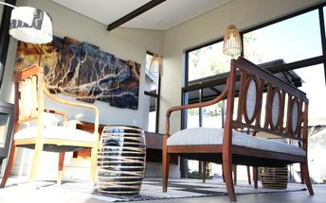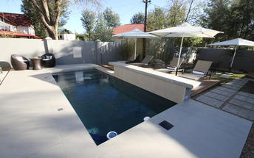

Meet and Greet
NTS Car Hire -Toyota Fortuner SUV Self-Drive
4x4 Toyota Fortuner
Adventure and luxury combine in this comfortable 4-wheel drive vehicle. This is the way to do a self-drive if you ask us. A lifestyle vehicle with the same "off road" performance as other 4x4's without feeling all the bumps along the way. Travel in style.
Includes:
- GPS navigation system
- 2nd spare tyre
- 24/7 Assistance
- Vehicle GPS tracker
- Airport return transfers

Basis
Bed and Breakfast

Day 2: Camelthorn Kalahari Lodge, Kalahari Namibia

Kalahari Namibia
The Kalahari is a vast basin of semi-arid plains, dry savannah and moist woodland. Welcome to wide open spaces and ochre red sands.
In the southern Kalahari, attractions are few and very far between and that in itself is one of the major attractions of this endless land. Large camel-thorns and shepherd's trees dot the grassy plains and your field of vision may well cross a time zone with enormous skies and a chirrupy silence your only companions.
The semi-arid plains and dunes support diverse and fascinating plants, birds and animals that have adapted to life in a virtually water-free world. The gemsbok can go for months on end without water and have special blood-cooling systems at the base of their brains. The camel thorn is a large and hardy acacia tree that thrives in sandy soils thanks to a taproot that can extend to three times the tree's height.

Day Itinerary
Windhoek – Kalahari 245km - approximately 3 to 4 hours
- After breakfast, you can still pop into town for anything you might need and then depart heading south from Windhoek to the red sand dunes of the Kalahari
- Spend the remainder of the day at leisure in this beautiful setting
- Optional activities here include game and nature drives as well as a Bushman experience

Overnight: Camelthorn Kalahari Lodge
In the vast Intu Afrika Kalahari Game Reserve, in southern Namibia, the Camelthorn Kalahari lodge provides you with accommodation on the doorstep of the astoundingly beautiful and serene Kalahari.
Wake up to a red glow from the sand dunes which surround this lodge and its 12 en-suite chalets. Natural materials like thatch, wood and reeds help to keep each room cool, especially in the summer when temperatures can reach 45°C. The swimming pool and shaded areas between the chalets offer some respite from the sun, when you get back from a day of animal spotting in the reserve.
The main lodge area and restaurant overlook a waterhole where giraffe, zebra and antelope come to drink. Make sure you take the time to see the enclosure which houses the two Kalahari lions, a predator which has recently been reintroduced to the reserve as part of their conservation efforts.
One of the distinguishing factors of this lodge is that you get to explore the bushveld with a San Bushman. Introducing you to the culture and way of life of this almost forgotten people, like hand-made weapon demonstrations, a look at some medicinal plants found in this area and animal tracking techniques – you will get some insight into what it takes to live in this harsh terrain.
Game viewing is done on foot or in 4x4 vehicles, which is a great mode of transport in the sandy Kalahari.
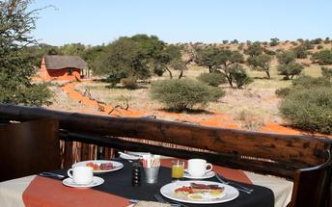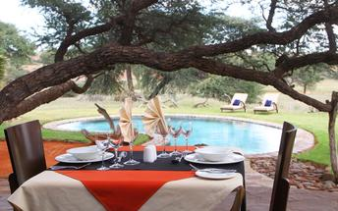

Basis
Dinner, Bed and Breakfast

Day 3: Canyon Roadhouse, Fish River Canyon

Fish River Canyon
The major attraction in the southern-most reaches of Namibia is the Fish River Canyon. One of the largest in the world, the canyon proper is about 60km long, up to 8km wide, and 550m at its deepest.
The ephemeral Fish River - one of a handful that rise in Namibia - began its work creating the canyon in about 170 million years ago when tectonic rumblings increased the gradient of the river.All around the canyon, the land rises and falls in gentle undulations marked by dramatic inselbergs. Hardy wildlife thrives in the unspoilt wilderness of two adjacent nature reserves: Fish River Canyon National Park and the privately-owned Gondwana Cañon Park.

Day Itinerary
Kalahari – Fish River Canyon 440km - approximately 7 to 8 hours
- Head south via Mariental and Keetmanshoop to the Karas region, the Fish River Canyon area
- Detour en-route to Giant’s Playground and Quiver Tree Forest, a beautiful site where large aloes grow between rocks
- Enjoy the view from the lodge at sunset to end the day

Overnight: Canyon Roadhouse View iBrochure
With bright and cheery rooms around a courtyard, a lively themed bar, and an al fresco terrace, the Canyon Roadhouse is another interesting addition to the portfolio in the private Gondwana Fish River Canyon Park.
Canyon Roadhouse is a roadhouse like no other because it's likely to be your destination. The upbeat and quirky décor barely disguises the age old coaching house of early pioneer days and the mood is set by a strong desire to go nowhere quickly.
Twenty four bright and comfortable en suite rooms line a courtyard - complete with all those the odd-looking plants that make you realise you're far from home - and there is a shaded campsite on the riverbed.
The living area features a lively bar and an á la carte restaurant dishing up hearty meals with fresh home-grown ingredients. The Kalahari is a hot, dry and dusty place, so the swimming pool is worth special mention here: large, cool and clean, it's almost as inviting as the cold beers in the bar.
The Canyon Roadhouse is en route to the Fish River Canyon and inside the Gondwana Canyon Park - a revelation of enterprise and home-brewed charm. The private reserve is twice the size of the Isle of Man and runs along the eastern edge of the length of Fish River Canyon conservation area.
The two other accommodation options in the park include the pioneer's farmhouse of Canyon Lodge and the rural inn of Canyon Village.
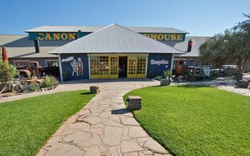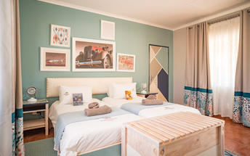

Basis
Dinner, Bed and Breakfast

Day 4-6: Alte Villa , Luderitz

Luderitz
Luderitz is a harbour town on the Atlantic Coast in Namibia with 25,000 inhabitants. Born out of necessity in 1487 when Bartolomeu Diaz sailed his little flotilla into the natural bay it now boasts German history, excursions to Kolmanskop Ghost Town and off-shore activities.
Visit the abandoned Kolmanskop Ghost Town. An eerie feeling as you walk through deserted houses now filled with sand. Explore the old diamond mines and restricted areas of Pamona and Bogenfels rock arch. Be on the look out for crystallised stones known as the "Desert Rose". Go to Diaz Point. See the lighthouse or go on a boat cruise of the seas to explore the harbour. Search for the desert horses of Aus. The last true herd of feral horses in Africa.

Day Itinerary
Fish River Canyon – Lüderitz 385km - approximately 5 to 6 hours
- Enjoy a morning canyon view before heading west through harsh but beautiful terrain which changes to wide open desert plains as you make your way to the coast
- Your drive will take you via Aus, where you may be lucky to view the wild desert horses in the area
- 1 full day is set aside to enjoy the historic town of Lüderitz and visit the amazing Kolmanskop Ghost Town
- Lunches and dinners can be enjoyed at any of the local restaurants in town

Overnight: Alte Villa
Alte Villa Boutique Guesthouse is for all the gemologists out there, those of you interested in diamonds. Close to where that first precious little nub of carbon was stumbled upon. Steeped, no, imbibed in history, Alte Villa Guesthouse is a real home of a guest house bang in the heart of colonial relic, Lüderitz.
Put your shades on and get ready for the outside of this place. It's yellow. Very. Once you've settled in you can walk to Lüderitz town and marvel at all that architecture. Think German. Think art nouveau. Think surreal. You’re there.
Alte Villa Guesthouse is not some old dinosaur - sure, it was built in another century, it was Friedrich III’s spin of the wheel if you’re being pedantic. But in 2017 it got a whole new look when the current owners rolled up with their new fangled restoring and renovating ideas. All homemade bread, apple pie and coffee. With decent decking furniture and the civility of a reading area off the breakfast room. Marvellous.
Alte Villa Guesthouse has just 6 rooms each with their own name (in German naturally), decor and decadence:
Rotes Zimmer - queen sized bed, ensuite, red walls with a glass chandelier. Pretty glam this one.
Zimmer Garub - named after a train station nuzzled by wild horses. Big photo of two rearing stallions. No pressure. Twin beds. Ensuite. Here’s the money shot though - along with the room called Grazplatz, it shares exclusive access to a living room. A beauty with a balcony with views of Luderitz harbour.
Grazplatz - see above for adjoining joy. Twin beds. Ensuite. A Zacharias Lewala vibe. He being the guy who found the first diamond in Namibia in 1908. Got rich he did.
Ichaboe - large 2 room apartment, 65sqm, twin bed in one room, 2 singles in the other. Kitchen, shared bathroom.
Tsiras - This is a 60 sqm double with its own private garden - you can have your breakfast al fresco here which is rather superb. There's a TV, a built in fireplace and ensuite.
Bogenfels - This is a large double, 57 sqm. This room has a sunny disposition and stares out to sea. Little wonder it's such a cheery number. It's got it’s own entrance in the front garden, twin beds and an ensuite.
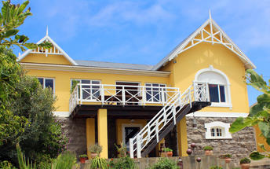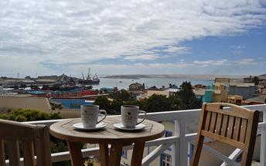

Basis
Bed and Breakfast

Day 6-8: Desert Quiver Camp, Sossusvlei

Sossusvlei
Star dunes with up to five crests rise 300m into the air and rank among the biggest in the world; the dune valleys are marked by vast clay pans where the Tsauchab River gave up its fight to reach the sea more than 60,000 years ago.
Besides the dunes and pans of Sossusvlei and Sesriem Canyon, a sideshow of activities and sights has developed around the region and there are plenty of game lodges that provide additional desert-adapted activities.Plants and birds are the dominant life form in this dessicated realm and they support a tiny world of mammals, reptiles and insects that, in the absence of coastal fog, seldom wander far from the rivercourse and its pans.

Day Itinerary
Lüderitz – Sossusvlei 505km - approximately 7 to 8 hours
- After breakfast, you will depart to the "sea of sand" backtracking to Aus and then heading north via Helmeringhausen
- Wake up early for breakfast (Day 7) and then head to the entrance to Sossusvlei, the Sesriem Gate
- Spend the whole day in the beautiful Sossusvlei area, exploring the highlights: Sossusvlei, Dead Vlei, Dune 45, Big Daddy, Elim Dune and the Sesriem Canyon
- Return to the lodge for lunch or arrange a lunch pack to enjoy in the dunes and return late afternoon for a well-earned rest
- Optional extra activities: Guided Sossusvlei excursion, Hot air balloon safari, Nature drives

Overnight: Desert Quiver Camp View iBrochure
With its quirky yet somehow harmonious design Desert Quiver Camp, near the entrance to Sossusvlei, can be a luxury camping experience, a back-to-basics desert lodge or both. And the best part - it's entirely up to you.
The 24 units, built of poles and canvas and stone, look like A-frames adrift and subsiding into the desert. The natural construction and sympathetic choice of colours help these structures blend into the dramatic scenery and, after a short while, the striking asymmetry becomes rather pleasing.
Inside, the rooms are spacious, cool and spotless. An en suite bathroom with shower, toilet and wash basin lurks behind the dividing wall and while the doorless layout - oddly popular among the newer establishments in Namibia - may not be to everyone’s liking, the spacious shower and piping hot water is a sure thing.
The unit has a large shaded porch with a kitchenette cunningly tucked away behind a canvas roll-down; the picnic bench and barbecue set the scene for a classic campout under the stars beside a flickering fire. A nice feature is you can order in your fresh cooking supplies and have them delivered to your unit.
If you’re not up to the ordeal of ready-steady-cooking your own meal or you just fancy a treat the camp’s sister property, Sossusvlei Lodge - well known for excellent service and quality food - is a few km up the road. As a guest of Desert Quiver Camp, you have full access to their activity centre, wonderful buffet restaurant, bar and pool all overlooking a waterhole.
Back at camp, a huge and ever-sparkling pool and its companion lopsided A-frame bar provide an agreeable venue for a sunset cocktail and a refreshing dip - the ochre view across the plains towards the rocky mountains is pure Namibia.
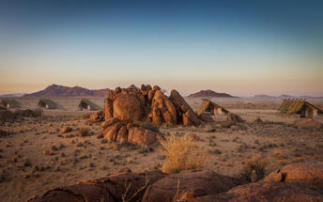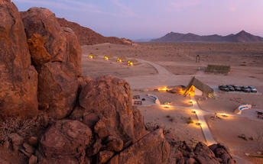

Basis
Dinner, Bed and Breakfast

Day 8-10: Swakopmund Luxury Suites, Swakopmund

Swakopmund
Surrounded by the ancient Namib desert and the inhospitable - but bounteous - Atlantic Ocean, Swakopmund is alive with activity and has a lot on offer for the adventure-seeker: quad-biking, sand-boarding, horse-riding, skydiving and more.
Swakopmund has many interesting German-influenced buildings from the early 1900s in a variety of styles and, for its size, Swakopmund has an astonishing array of restaurants that serve mainly seafood, steak and many German staples.

Walvis Bay
Walvis Bay is an industrial port which lies along the Atlantic Ocean, off Namibia's Skeleton Coast. The large bay and surrounding sand dunes help make Walvis Bay a tourist mecca with loads of activities on offer to explore it.
- Explore the Skeleton Coast where the dunes meet the sea at Sandwich Harbour‍
- Go on a dolphin boat cruise in the harbour. Enjoy champagne and oysters
- Kayak among the seals at Pelican Point
- Visit and climb the mighty Dune 7‍
- Visit the RAMSAR wetland birding site and the Walvis Bay Lagoon. Thousands of flamingos from October to April‍
- Explore the neighbouring town of Swakopmund. Activities abound and dining delights

Day Itinerary
Sossusvlei – Swakopmund 350km - approximately 5 to 6 hours
- Depart after breakfast and head north to Solitaire, then west crossing the Tropic of Capricorn, through the Gaub and Kuiseb Canyons via the Namib Gravel Plains to the coast
- Either via Walvis Bay to Swakopmund, or (recommended) detour via Ganab to the Welwitschia Plains and Moon Landscape
- The Namibian coastline is generally known as The Skeleton Coast due to the barren areas, ship wrecks and, in days gone by, whale skeletons left on the beach
- 1 full day is set aside for this lovely area where Swakopmund and Walvis Bay offer a wide range of activities such as: Dolphin cruise, Sandwich Harbour excursion (a real Skeleton Coast experience), Dune quad biking, Sand boarding, Sea kayaking, Lots more…
- Lunches and dinners can be enjoyed at a café or restaurant overlooking the sea

Overnight: Swakopmund Luxury Suites
Swakopmund Luxury Suites pack comfort and convenience into an elegant apartment-style accommodation option in the belly of Swakopmund's restaurant quarter.
Although “suites” is a bit of stretch size-wise, for comfort you can expect elegant, neutral décor that is easy on the senses and top quality linen with quite possibly the most comfortable bed you’ll encounter on your tour of Namibia. Attention to detail includes Nespresso machines with complimentary pods, bath robes, extra thick towels, wi-fi that actually works, climate control, mini-bar and that general air of purpose and cleanliness of a professional outfit.
For convenience you are a few minutes’ walk to the beach, restaurants, cafes and main attractions of central Swakopmund - a feature you will welcome after many hours’ in the car on Namibia’s long and dusty roads. And the day reception is staffed with the friendliest of friendly Namibians who add that personal touch and valuable insider’s information for making the most of your visit.
A secluded upper deck lined with comfortable recliners and deck chairs is a wonderful place to catch up with your digital life. Or escape it entirely with a good book and a glass of chardonnay. Parking out front is secure with 24-hour watch and CCTV and, occupying the first storey down a pedestrianised side street, the location is quiet and safe.
Breakfast at the Swakopmund Luxury Suites is a delight. The breakfast room is stunning and the food is delicious. A great way to start your day before you head off to explore where the dunes meet the sea. You are just a short walk to the main beach and the main streets of town. Splendid.
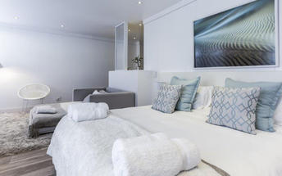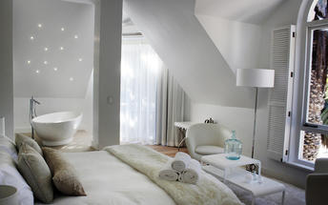

Basis
Bed and Breakfast

Day 10: Twyfelfontein Adventure Camp, Damaraland

Damaraland
Damaraland features vast khaki plains, sheer rocky mountains and incredible desert-adapted wildlife. Track rhino and desert elephant, explore the rugged land or sit back and enjoy the dramatic and endless scenery. Damaraland's hilly savannah supports a large number of species including lion, leopard, cheetah, hyena, eland, kudu, giraffe, klipspringer, steenbok, gemsbok and springbok. Birdlife is prolific with over 33 raptors recorded including cuckoo hawks, Egyptian vultures and peregrine falcons - the world's fastest animal.
Damaraland is divided into several enormous private game reserves, known as concessions, that support most species of Namibia's large game and provide some of the best birding and wildlife experiences in the country - and southern Africa for that matter.

Day Itinerary
Swakopmund – Damaraland 445km - approximately 7 to 8 hours
- Head north along the Skeleton Coast, via Henties Bay to visit the Cape Cross seal colony. Along the way, stop at the Lichen Fields as well as the ship wreck between the colourful small town of Wlotskasbaken and Henties Bay
- Backtrack to Henties Bay and head inland through wide open plains to Uis, then north to the Twyfelfontein area
- Visit to Namibia’s Open Air Museum, the Twyfelfontein Rock Engravings as well as the interesting Organ Pipes rock formations and Burnt Mountain
- Visit the Damara Living Museum for a hint of culture

Overnight: Twyfelfontein Adventure Camp View iBrochure
Against and among the granite boulders, Twyfelfontein Adventure Camp has prime location for visiting the highlights of the area. From here you can easily explore the heart of Damaraland, the sights of Twyfelfontein and track desert-adapted elephants.
Within walking distance of the Damara Living Museum, Twyfelfontein Adventure Camp is a 10-minute drive from the Twyfelfontein Rock Engravings, Burnt Mountain and Organ Pipes. Situated in the Huab River Valley, there’s a chance the elephants could stroll past your tent at any moment or at the least, you won’t have to venture very far to find them.
Location is key and in that category Twyfelfontein Adventure Camp is a winner. It’s been a long day's drive from any direction to get here, so once you’ve arrived, it’s great knowing you won’t have to spend much time in the car to explore the area. Less time on the road means more time for adventure and to laze at the glistening pool with a drink in hand. Of equal importance when on holiday.
The eco-friendly camp has both standard and premium tents. The standard tents are just that, they are small and basic but tasteful and charming. The premium tents are more luxurious, both in the decor and the space. You have some added extras, a bigger room, a bigger bathroom, comfortable inside seating and a small fridge.
The main lodge area is rather lavish and quite ornate, shared by all guests for meals and to relax. There is a second more relaxed 'chill' area too and two swimming pools, one at each. Add the view and you’ll be delighted to call this home for the next few nights. Two-night stays allow you to book a spectacular guided nature drive in an open safari vehicle.
Jumbled sandstone hills, platinum-blonde savannahs and olive-green shrublands make this landscape of incredible scale, colour and silence - so much silence - a marvel. See the many wildlife species that thrive here and learn how humans and wildlife including elephant, lion, rhino, antelope varieties and smaller predators have adapted to life in a land so hot and dry that it becomes ever more a wonder.
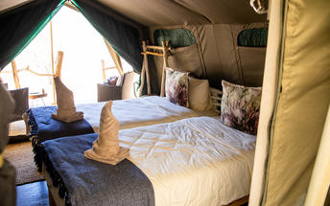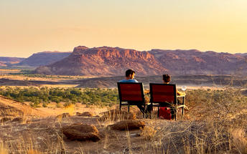

Basis
Dinner, Bed and Breakfast

Day 11: Opuwo Country Lodge, Kaokoveld

Kaokoveld
The Kaokoveld, a vast and empty wilderness occupying the north-western quarter of Namibia, is roughly divided in two by the Hoanib River. It’s harsh, remote, unpopulated and makes for some of Namibia’s finest scenic landscapes.
Kaokoland is a succession of hills and mountains punctuated by endless plains. This isolated rugged region is home to the nomadic Himba pastoralists who have remained unchanged for many generations. The attraction of Kaokoland lies in its wild and uncharted valleys and mountains. It is the most isolated and undeveloped region of this mostly isolated and undeveloped country.

Day Itinerary
Damaraland – Opuwo 340km - approximately 5 to 6 hours
- Depart the Twyfelfontein area and head north via Palmwag, crossing the Hoanib River, up and over Joubert Pass to Opuwo, the centre of Kaokoland
- Opuwo is a small typical African town, where a range of different people live, from the traditional Himba tribes to Herero, Damara and Owambo cultures
- Along the way stop at various villages to interact with and photograph the local people
- Depending on arrival time, enjoy a Himba village visit this afternoon. It is recommended to arrange a local guide to go with you (lodge reception can assist with this)

Overnight: Opuwo Country Lodge View iBrochure
The Masai-like Himba people of Kaokoland have retained their traditional semi-nomadic lifestyle. Their land is harsh, inhospitable and fascinating, creating a delicate balance between survival and obliteration.
The Opuwo Country Hotel (also known as Opuwo Country Lodge) overlooking the untouched wilderness, provides a comfortable base from which to explore this beguiling region and to discover the secrets of its proud inhabitants. The lodge is also an excellent base for exploring the Kunene River and the far flung moonscape of valleys, mountains and ravines.
The luxury hotel opened late in 2005, and the rooms are all air conditioned and have en suite bathrooms. It's certainly not luxury compared to other high-end lodges throughout Namibia, but in these parts it's the most luxurious option there is and given the setting it's more than suitable. The air-conditioning alone takes the win.
The main living area houses the bar, restaurant, lounge, wine cellar, curio shop and a large verandah with a view that starts at the pool, sweeps over a mopane-covered valley, and ends in a haze of mountains.
Opuwo means "finished" or "up to here and no further" but really you can continue to the more northern reaches of Namibia from here and if you are heading in that direction, then you are almost certainly guaranteed to stay here along the way.
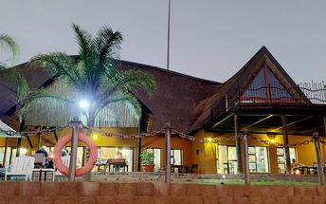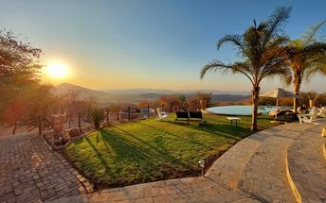

Basis
Dinner, Bed and Breakfast

Day 12-14: Epupa Camp, Kunene

Kunene
Bordering Angola in northern Namibia, Kunene is a region as well as the name of a river, which is one of just five perennial rivers in Namibia. The Kunene River is an invaluable source of water for the local Himba people, and it has been the mainstay of their existence for hundreds of years. For travellers, the river’s most striking feature is the magnificent Epupa Falls, which cascade over a distance of more than a kilometre downstream, with an impressive vertical drop of around 60 metres. Whitewater rafting and kayaking are both popular pursuits in these areas. Visitors can take sundowner cruises; explore sublime hiking routes; enjoy excellent bird watching opportunities; learn about local culture with a trip to a traditional Himba village; or go canoeing, kayaking, and game viewing.

Day Itinerary
Opuwo – Epupa Falls 180km - approximately 3 hours
- Today takes you way north to the border with Angola, the beautiful Epupa Falls
- 2 nights, a full day is set aside here to visit some authentic traditional Himba villages, view the falls and hike along the Kunene River
- Plan a morning visit to 1 or 2 authentic Himba villages as this is when there is the most activity

Overnight: Epupa Camp View iBrochure
On the edge of the southern bank of the Kunene River, the lodge and campsites are nestled as an oasis under the wild figs, makalani palms and baobabs. A retreat in an otherwise harsh and remote area of pure beauty and although it’s not luxury, it’s a notable step up from other more basic tented camps you might come across.
Vast Meru-style tents on stone platforms peak out through the trees, with shaded patios just a few metres above the grey-green Kunene River swirling below. Venture too far and you’re likely going for a swim, not recommend with crocodiles lurking nearby. Each of the ten tents is fitted with an en suite bathroom with hot running water. Simple but all you need.
If you’re looking to camp, then you can either set up camp yourself or enjoy a tented campsite all ready for you to move in. Ten dome tents housing 2 single beds each. The same experience as traditional camping, only the campsite is set up for you. Overlooking the river with private ablution facilities (open-air), fire place and sink. Request your firewood and simply enjoy the tranquillity.
Essential in the heat, the swimming pool is a welcomed delight and with a view, it’s the perfect spot to cool off and relax. Head across the bridge to the private island and explore. Enjoy the outdoor bar and a sundowner and at night the romantic setting for dinner under a canopy of stars.
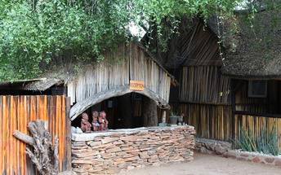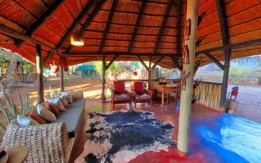

Basis
Dinner, Bed and Breakfast

Day 14: Hobatere Lodge, Etosha West

Etosha West
Situated in the western part of Etosha National park, a world-famous wildlife sanctuary in the northwestern part of Namibia, Etosha West is the wilder western region accessed through Galton Gate. Visitors to Etosha West can look forward to exploring the magnificent scenery of this remote north Namibian landscape characterised by lush undulating terrain and a reddish-brown soil, which is a stark contrast to the white dusty clay soil of Etosha East’s flat expansive plains. This area is home to several species not found in the rest of the park: baboons, Mountain Zebra, and Brown Hyena, as well as several unique plants. The area also boasts numerous waterholes attracting elephant, rhino, leopard, lion, a variety of buck, and around 300 bird species.

Day Itinerary
Epupa Falls - Etosha (west) 375km - approximately 5 hours
- Depart this morning after breakfast and backtrack to Opuwo before heading east and then south towards the west side of Etosha
- Arrival here will be in the afternoon and if you wish, join an afternoon or evening game drive on the private reserve (optional extra)

Overnight: Hobatere Lodge View iBrochure
Hobatere is an 8,000-ha community-owned concession managed by Journeys Namibia who run the wonderful Grootberg Lodge along the same lines and also manage the successful Fish River Lodge, so they’re no strangers to the business.
West of Etosha, Hobatere is the complete safari experience and the only complaint we’ve ever had about this place is that we didn’t book our clients in for long enough. The refurbished thatch chalets are not overly luxurious - there’s no air conditioning for example - but they remain secluded and spacious with comfy beds, an en suite bathroom (shower only, this is an eco-camp after all) and a private balcony.
The main building faces the waterhole about 200m away and you can spend all day watching elephants, lions, cheetah, leopard, giraffe, zebra and all manner of antelope; birding is still excellent of course as is the quality of the guiding.
The food is excellent the highlight being a three-course set menu dinner and the staff, who are all custodians of the conservancy, are friendly, keen to help and, with first-class training from Journeys Nam, pretty good at what they do.
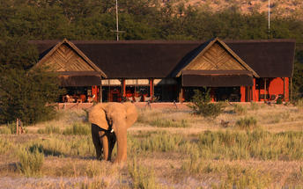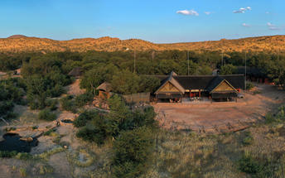

Basis
Dinner, Bed and Breakfast

Day 15: Etosha Village, Etosha South

Etosha South
Located just south of the boundary of Etosha National Park in northwestern Namibia, Etosha South makes up the southern region of this wild paradise. The area is comprised of a collection of world class private game reserves. The national park can be accessed via the southern entrance at Andersson’s Gate. Visitors can catch a glimpse of a variety of wildlife including: lion, giraffe, elephant, white and black rhino, and a multitude of plains game. Popular activities include: enjoying an open 4x4 safari with an expert guide, half day or full day drives with the option of a picnic lunch with wine on the full day game drive.

Day Itinerary
Etosha (west) – Etosha (south) a full days game drive through the park
- After breakfast, enter Etosha at the western Galton Gate, a full morning game drive to Okaukuejo and exit Etosha at the southern gate, Andersson gate
- Return into Etosha for an afternoon drive or arrange with the lodge for a game drive (optional extra)
- At Okaukuejo, I suggest you pop in at the local shop to purchase some drinks and snacks and most importantly, a map of Etosha which will show you all the waterholes in the park
- Etosha is one of Africa's great game parks. With 114 species of mammal and 340 species of birds you are sure to see a great variety of wildlife on your safari.

Overnight: Etosha Village View iBrochure
Even before its hard refurb, Etosha Village was probably the best value safari lodge in Etosha. Replacing all tented accommodation with smart air-conditioned chalets, Etosha Village is now by far the best value safari lodge in Etosha.
Retaining its eco-conscious credentials - the bricks were salvaged from mining debris, grey water is filtered and re-used in the vegetable garden, water is solar heated and the kitchen produces a fair amount of high-quality composting material - Etosha Village had a major refurbishment in mid-2016 and what an upgrade.
Brick has replaced canvas, sleek tiles have replaced creaky wood decking and the en suite bathrooms are smart, shiny and functional. From the outside, the chalets are full of life and texture with gabion foundations, balustrades filled with pebbles, a gravelled forecourt and woven latte poles covering the roof. Inside, while a tad on the austere side, the rooms are spacious, practical and well-appointed with air conditioning, en suite bathroom, sofa bed good for two under-12s (the Village is one of a few child-friendly safari lodges in Etosha), fridge, tea/coffee, safe, balcony and a large gazebo to the side. Comfortable twin beds with soft cotton are a given.
The living areas have also retained their charm and casual comfort with a large swimming pool surrounded by loungers and parasols and a smaller pool adjacent to a third toddler-friendly pool. The food at Etosha Village is fresh and the staff here, recruited from the nearby village and trained in-house, are famous for their friendly and enthusiastic service.
Breakfast and dinner are sizeable buffet spreads and lunch is a small a la carte menu with local venison specialities. Tea, coffee, hot chocolate and juice are on the house all day and the open-air bar is a convivial spot to share a drink and a tale or just gaze into the night sky as is your want.
Being just minutes from the southern gate is ideal for daily access to Etosha National Park for guided game morning and evening drives in an open-sided safari vehicle. The vehicles accommodate up to 10 people and if that’s a bit crowded or constrained, Etosha is one of the easiest self-drive game reserves in Africa: arm yourself with a prepared breakfast and lunch or a picnic hamper from the well-stocked supply store and spend the day at any number of quiet waterholes. A good reference book, binoculars and of course your camera should be required equipment.
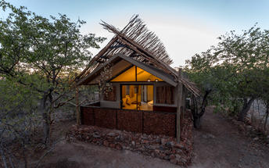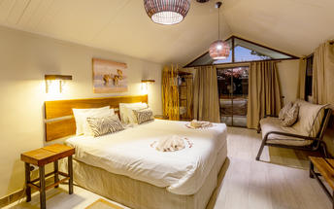

Basis
Dinner, Bed and Breakfast

Day 16-18: Onguma Bush Camp, Etosha East

Etosha East
On the eastern edge of Etosha National Park, the park itself is bordered by numerous private reserves and access into the park is via the Von Lindequist Gate, named after Dr. Friedrich von Lindequist who proclaimed it a game reserve in March 1907. This side of the park is characterised by flat endless plains, tree-savanna type of vegetation and fantastic waterholes, where you could easily spot any of the prolific wildlife Etosha is known for. There's an abundance of wildlife here.

Day Itinerary
Etosha (south) – Etosha (east) a full days game drive through the park
- From one side to the other side of the park is a full day game drive as you head slowly east stopping at numerous waterholes along the way
- Take a slow drive in the morning and then enjoy a snack or lunch overlooking one of the waterholes before continuing on through the park to the eastern side
- 1 full day is set aside for game viewing, either all day or alternate with morning and afternoon drives. These are self-drive game drives but you can arrange at the lodge to go with their open safari vehicle and guide (optional extra)

Overnight: Onguma Bush Camp View iBrochure
Onguma Bush Camp is a comfortable, family-orientated lodge in a private reserve on the eastern edge of Etosha National Park. With 18 rooms including family suites as well as a small campsite, the atmosphere is tranquil and casual.
Onguma Bush Lodge is an alternative to staying inside Etosha National Park where your options are limited to three basic state-owned camps.
This comfortable lodge is located on the edge of the park near Fisher's Pan and the eastern entrance to Etosha. The rates are reasonable and the lodge is neat, small and an excellent base for families.
The en suite, air-conditioned rooms are built from local stone and have thatched roofs. The pool, open-air lapa and dining area provide the venues for some pleasant banter, spectacular sunsets and hearty meals. The lounge and dining area overlooks a waterhole for around-the-clock game viewing. The campsite has six sites with private ablutions and firewood; campers are welcome to make use of the bar, pool and restaurant.
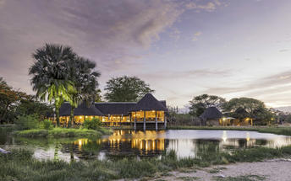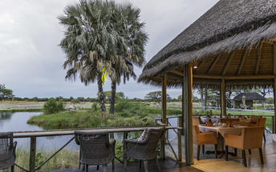

Basis
Dinner, Bed and Breakfast

Day 18: Otjiwa Safari Lodge, Waterberg Region

Waterberg Region
Namibia's Waterberg region is a wildlife haven en route to Etosha National Park. Several excellent game farms have developed over the years and offer exceptional private safaris with luxury accommodation and good numbers of Africa's big game. The Cheetah Conservation Fund is several amalgamated game farms with private lodges on the western side of the Waterberg Plateau Park. The AfriCat Foundation is on the private Okonjima Nature Reserve, where they rehabilitate animals such as cheetah to be re-released into the wild.
The Waterberg plateau rises 200m above the surrounding plains and creates a diversity of habitats. The Waterberg Plateau Park and surrounding game farms are the base for numerous conservation-related research projects.

Day Itinerary
Etosha (east) – Otjiwa 330km - approximately 4 to 5 hours
- Head south via Otavi and Otjiwarongo to Otjiwa, which is the oldest private game farm in Namibia, and offers about 25 different game species, this includes the White Rhino, Sable and Roan.
- Enjoy many of the optional activities like sundowner drive, game walks, rhino tracking and night drives.

Overnight: Otjiwa Safari Lodge View iBrochure
If it ain’t broke, don’t fix it. Otjiwa Lodge is the perfect example of that. The oldest game farm in Namibia and home to over 25 game species. It goes to show - an oldie can still be goodie.
Otjiwa Safari Lodge is a 30-minute drive from Otjiwarongo, less than an hour from Waterberg and close enough to Windhoek (on tarred roads) to make this your first or last destination in Namibia.
This game farm has numerous accommodation options:
At Eagle's Rest there are the family units and the elegant rooms.
The family units have two bedrooms, a kitchenette, a lounge, parking and since you probably want family time. It is also self-catering, which is ideal since we know that kids can be fussy eaters and mom knows best.
The elegant rooms, on the other hand, are not self-catering. You can lounge around on the private patio or in the room itself in front of the TV and air conditioning. If we're being honest, these rooms are more standard than they are elegant but offer the necessary comforts and some finer elements of luxury.
All the rooms come with access to a pool, WiFi (at the business centre) and the restaurant.
Large groups or families can stay at The Nest, a self-catering cottage with views over a floodlit waterhole. This house has 3 bedrooms, sleeping up to 12 people on beds and sleeper couches. The kitchen is big enough for everyone to feast, but dinner is best served with the view at the outside 'braai'. To keep yourself busy (and great for the kids) there is a small shaded pool for you to take advantage of.
Otjiwa Lodge is an oldie but a goodie. This is a place to just kick your feet up with a book and a drink or bond with your entourage by the pool while you enjoy a barbeque. The simple pleasures are all you really need here anyway.
For something more upmarket, you can stay at the Mountain Lodge - a more intimate and luxurious option with only 5 chalets, each with its own private patio and plunge pool.
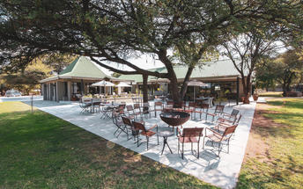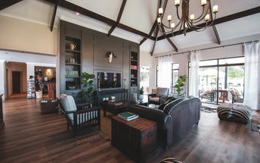

Basis
Dinner, Bed and Breakfast

Day 19: End of Itinerary

Day Itinerary
Otjiwa– Windhoek 225km - approximately 3 to 4 hours
- Early morning rise for a quick snack before joining an optional morning activity
- Back to the lodge for a hearty Namibian breakfast before departure
- Head back to Windhoek, where you will drop off your vehicle and transfer to the airport in time for your departure flight (Keep in mind that you need to be at the airport 2 hours prior and the airport is still a 45 minute to 1 hour drive from town)

Basis
Bed and Breakfast

Transport

Transfers
Date | Company | Pick Up | Drop Off | Time | Vehicle
 |  | Hosea Kutako International Airport [WDH] | Windhoek City |  | Transfer
 |  | Windhoek City | Hosea Kutako International Airport [WDH] |  | Transfer

Terms and Conditions

Africa Travel Tours Terms and Conditions
Contract
1.1 The contract will become effective as from the date the invoice is completed and the deposit, referred to in Clause 2.1, is received by Africa Tours & Safaris CC (hereinafter known as the Company).
1.2 The contract is subject to the Namibian Law.
1.3 Any person making a reservation as per Clause 8.4 accepts the terms and conditions of this agreement set out hereunder.
How to Book
2.1 A 20% deposit of the full amount due is required to confirm any reservation and is to be done by the agent or client (see Clause 8.1) in writing or by e-mail.
2.2 The Company must receive the balance of the contract price no later than 42 days (6 weeks) prior to departure.
2.3 If the Company does not receive the full contract price 42 days (6 weeks) before the departure date, the Company may cancel the reservation and retain whatever deposit or other funds it has already received from the client or his agent.
How to Pay
3 The payment options will be provided upon confirmation of a booking.
Our Cancellation Policy
4.1 Any cancellation of a confirmed booking must be done in writing (email) to the Company whereupon cancellation charges as per Clause 4.2 will apply.
4.2 The following cancellation fees (as a percentage of the fully quoted price) are applicable to any cancelled travel:
Notice from date of travel: Cancellation fee:
42 days or more 20% (deposit forfeited)
29 – 41 days 50%
15 – 28 days 75%
0 – 14 days 100%
Please note: the notice period is calculated from the date of cancellation to the start date of the tour/safari booking.
4.3 No refund will be made by the Company if, for any reason, inclusions or parts of the tour cannot be carried out / or utilised. These would include all facets such as meals, game drives, accommodation etc. This would also apply to any client who has booked a tour but fails to undertake the tour for any reason.
Our Changes Policy
5 If a booking is changed to an earlier date than originally reserved, the Company will endeavour to change it. If the booking is for a later date, charges as per Clause 4.2 could apply.
As things go, we've all had to adapt to changes during the Coronavirus pandemic and so too have we therefore amended our terms and conditions for travel during such times. Check out the Updated COVID Terms and Conditions here.
Price Changes
6.1 The Company reserves the right to increase the price of any tour prior to departure due to factors beyond the control of the Company, such as, without being limited to, and increase in fuel prices, new Government legislation, accommodation price increases, fluctuations in exchange rates, etc.
6.2 If the Company announces an in increase in the tour price in terms of this Clause, such addition amount must be paid to the Company before the departure of such tour or else the Company shall have the right to cancel the tour and the charges in Clause 4.2 will apply.
Changes to Itineraries
7 The Company shall at any time have the right, in its entire discretion, to alter the terms of the booking in relation to the route, timetable, itinerary and accommodation. The Company shall, however, make every effort to offer the client an alternative tour of a comparable standard.
Should the alternative be of a lesser standard, the client will be refunded the difference, but should there be an increase, the client shall have the right to either reject the alternative and obtain a refund of the relevant portion of the original contract sum, or to accept the alternative and pay the increased cost. In the event of the client rejecting the alternative tour and claiming a refund, such rejection will be treated as a cancellation and the refund will be calculated according to Clause 4.2 hereof. The client shall have no claim against the Company for any damages arising out of the alternative booking.
Responsibility and Liability
8.1 Neither the Company nor any person acting for through and on behalf of the Company shall be liable for any loss or damage whatsoever arising from any cause whatsoever and without restricting the generality of the aforegoing shall particularly not be responsible for the loss or damage arising from any errors or omissions contained in its brochure or other literature, late or non-confirmation or acceptance or bookings, loss or damage caused by delays, sickness, injury or death, whether occasioned by negligence or not.
8.2 The Company shall have the right at any time at is sole discretion, to cancel or the remainder thereof or to make an alteration in the route, accommodation price or other details. This would include any event of any tour being rendered impossible, illegal or inadvisable by weather, avalanches, strike, war, government or other interference or due to any other cause whatsoever. The extra expenses incurred as a result thereof shall be the responsibility of the client.
8.3 The Company may at its discretion and without liability or cost to itself at any time cancel, or terminate, a client's booking and in particular, without limiting the generality of the aforegoing, it shall be entitled to do so in the event of illness or the illegal or incompatible behaviour of any client undertaking the tour, who shall in such circumstances not be entitled to any refund.
8.4 Any person making a reservation with the Company (refer to Clause 1.1) warrants that her or she has the necessary authority to enter into this contract on behalf of the person or persons included in such a booking. The person making the reservation shall be liable for the total amount due to the Company.
Client's Obligations
9.1 It is the onus and responsibility of the client to obtain the necessary comprehensive insurance before departure for any possible cancellations, medical expenses, protection or personal property and money.
9.2 The onus is upon the client to ensure that passports and visas are valid for the duration of the safari. The Company cannot be held liable for any necessary visas or other travel documents not held by clients. In the event of a client not having the necessary documentation to enter any area or country the Company shall reserve the right to leave the client a the point of entry of such area or country. In such an event, the Company will not be held responsible to the client for further travel arrangements.
9.3 The onus is upon the client to ensure that the SARS-CoV-2 PCR tests are done prior to commencement of the safari and valid on arrival in accordance to the requirements of the country of intended travel and for the airline with which the client will travel. The same applies for any necessary testing for departure. The costs of any such COVID testing will be for the clients own account. While The Company can assist with arrangements for testing in-country, The Company will not be held responsible to the client for such arrangements and with regards to return time of test results.
9.4 Should the client need to undergo mandatory quarantine once in-country with regards to the SARS-CoV-2 virus, either on arrival as called for by the authorities or due to testing positive once in-country, this will be at the clients own expense.
Health and Personal Safety
10.1 The client shall be reasonably fit to undertake the tour.
10.2 Anti-malaria precautions should be commenced prior to tour departure. A medical doctor should be consulted for advice.
10.3 Tours offered by the Company cover a wide spectrum of the African wilds and neither the Company, its employees or agents can be held responsible for any injury or other related incidents whilst on the tour / safari.
10.4 The Company cannot be held responsible for any client who falls ill or contracts the SARS-CoV-2 virus while in-country. The client accepts that travel is at own risk.
Baggage
11.1 Clients are limited to one soft sports type bag per person with a maximum weight of 20 kilograms. This includes photographic equipment and hand luggage.
11.2 Due to the rugged terrain, the Company cannot be held responsible for damage or loss of any personal items including bags, contents of bags or photographic and related equipment. Due to extremely dusty conditions, please ensure all bags are dust proof.
Airline and Car Hire Clause
12.1 The Company will act as the agent of the client when booking the client with a car hire company, an airline or air charter service. The client therefore contracts with the car hire company, airline or charter service and not with the Company.
12.2 Charter flights are normally operated by smaller type aircraft such as Cessna 210. Luggage is strictly limited to 10-15 kgs (depending on terms of particular airline used) per person in soft hold all type bags. Due to the desert heat, it is not safe to overload aircraft thus this limit needs to be strictly controlled.
Travelling or thinking of travelling during the COVID-19 pandemic? Take a look at our COVID Terms and Conditions for more information on how this will work and differ from our standard terms and conditions as listed above.

