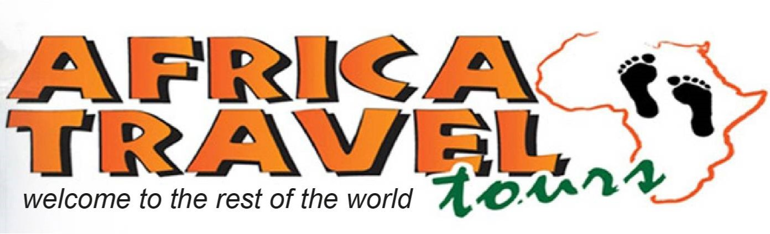
432 Miles Road, Victoria Falls, Zimbabwe, Tel: +263 83 2845017/8, Cell: +263 772 747 993 / 263 712 375 138, info@africatravelvicfalls.com www.africatravelvicfalls.com

7-Day Desert, Dune & Wildlife Fly-in Safari - Luxury -
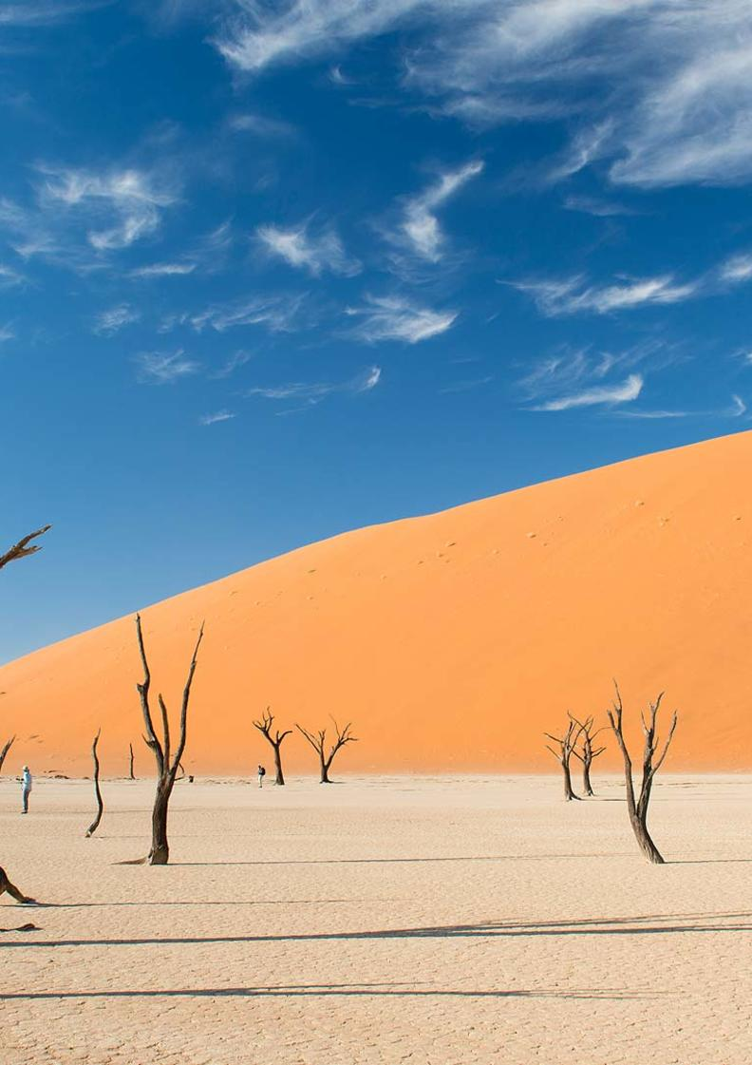
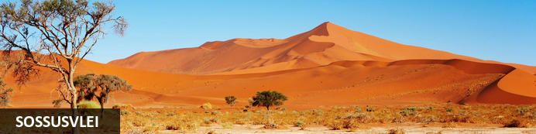
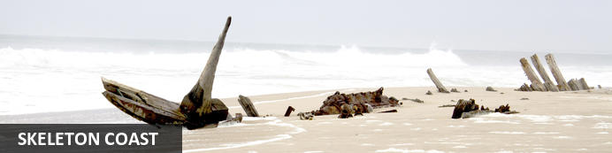
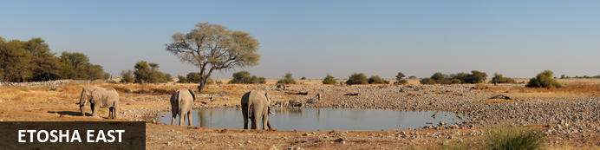

7-Day Desert, Dune & Wildlife Fly-in Safari - Luxury
Sossusvlei - Skeleton Coast - Etosha East
7 Days / 6 Nights
Reference: 2024
Date of Issue: 12 September 2023

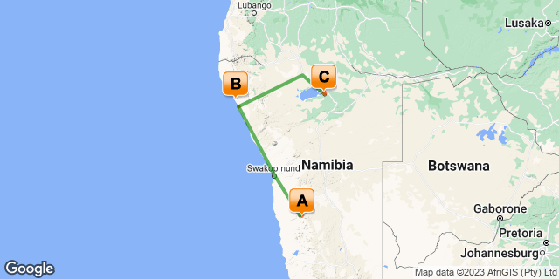

Click here to view your Digital Itinerary

Introduction
This 7-Day Desert, Dune & Wildlife Fly-in Safari is the ultimate trip to some of Namibia’s best highlights: Sossusvlei, Skeleton Coast and Etosha National Park.
Visit the Namib Desert; a sea of dunes, a great sand sea. The only true African desert south of the equator. Then you’ll fly high along the Skeleton Coast to Swakopmund and onwards to your lodge further up the Skeleton Coast before exploring Etosha National Park to end.
This suggested itinerary can be changed and areas added to make it even better:
- Add the north west to visit traditional Himba tribes;
- And/or the rugged landscapes of the Damaraland area and the desert adapted wildlife.
- Even better, add the Caprivi Strip area whether around Popa Falls or the Kwando River.
- …. Many options available.

Accommodation | Destination | Basis | Duration
Hoodia Desert Lodge | Sossusvlei | FI | 2 Nights
Shipwreck Lodge | Skeleton Coast | FI | 2 Nights
Onguma The Fort | Etosha East | FI | 2 Nights

Key
B&B: Bed and Breakfast
FI: Fully Inclusive - Bed, All Meals, Fees and Activities

Price
1st January – 30th June 2024 – Low Season
2 guests - USD 8 520 per person sharing
4 guests – USD 6 480 per person sharing.
Single supplement – USD 1 920
1st July – 31st December 2024 – High Season
2 guests – USD 9 000 per person sharing
4 guests – USD 6 720 per person sharing.
Single supplement – USD 2 100
Flight costs are calculated on a private charter basis in a Cessna 210 aircraft.
Prices subject to change according to fuel price fluctuations.

Included
- Accommodation as indicated – can change depending on availability and request at time of booking.
- Meals as indicated
- Meet and greet upon arrival
- Activities as indicated including park entry fees
- Private charter flights as indicated
- Airstrip transfers as necessary
- Tour file with detailed itinerary, map with route descriptions, vouchers etc.
- 24 hour personal and friendly support
- Fast and efficient response to service providers

Excluded
- Items of a personal nature
- Optional extra activities
- International flights
- Holiday or personal insurance
- Staff gratuities
- Visas and visa applications

Day 1-3: Hoodia Desert Lodge, Sossusvlei

Sossusvlei
Star dunes with up to five crests rise 300m into the air and rank among the biggest in the world; the dune valleys are marked by vast clay pans where the Tsauchab River gave up its fight to reach the sea more than 60,000 years ago.
Besides the dunes and pans of Sossusvlei and Sesriem Canyon, a sideshow of activities and sights has developed around the region and there are plenty of game lodges that provide additional desert-adapted activities.Plants and birds are the dominant life form in this dessicated realm and they support a tiny world of mammals, reptiles and insects that, in the absence of coastal fog, seldom wander far from the rivercourse and its pans.

Day Itinerary
Flight: Windhoek – Sossusvlei 1 hour & 10 minutes
- You will be met on arrival by our representative to hand over your travel documents
- Meet your pilot and check in for your flight and briefing before taking to the Namibian skies
- Private charter flight from Windhoek to Sossusvlei over the Namib Naukluft Mountain Range
- Road transfer to the lodge on arrival
- 2 night FI package includes: Dinner, bed & breakfast; 1 x lunch on day of arrival or lunch packs on day of departure; 1 x Sundowner drive; 1 x Guided Sossusvlei excursion including a full picnic lunch in the dunes; Local branded drinks
- Highlights: Sossusvlei, Dead Vlei, Dune 45, Big Daddy, Elim Dune and the Sesriem Canyon

Overnight: Hoodia Desert Lodge
Hoodia Desert Lodge prides themselves on offering immaculate accommodation, personal and attentive service and that all incredible setting, so close to the highlights of the area, in the world's oldest desert.
Thomas and Henreza are the consummate hosts and their attention and enthusiasm are evident in every detail. From the warm welcome to the personalised recommendations what to do during your stay, they stop at nothing to ensure you have the best possible Sossusvlei experience.
Hoodia Desert Lodge is built on a small outcrop ringed by the Namib-Naukluft Mountains on the banks of the dry riverbed rising from that same spectacular mountain range. You are about 30 minutes’ drive to the entrance of Sossusvlei Park, which means you are far enough away to enjoy total peace and quiet but close enough to Sossusvlei to enjoy a full day among the world’s tallest dunes in the world’s oldest desert.
With just 11 chalets, Hoodia Desert Lodge is intimate and quiet. Each room is beautifully furnished with the unique desert colours and textures as inspiration. An outdoor shower or bath in the desert is something to remember for a long time. A large and shaded verandah encourages long lazy days soaking up the ancient stillness of the Namib Desert and if it all gets too much, you can cool off in the plunge pool at the main lodge.
Dining is an experience in itself with Henreza taking great pride in her fair that extends beyond the meat-heavy traditions of Namibia; the wine list pairs well with the variety of dishes and be sure to ask for an al fresco lunch or dinner to top it all off.

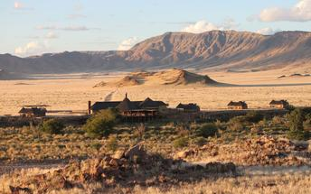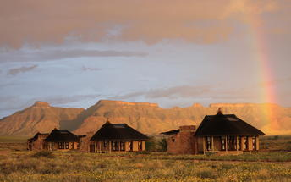

Basis
Fully Inclusive - Bed, All Meals, Fees and Activities
All Drinks (excl Premium Brands) Included

Day 3-5: Shipwreck Lodge, Skeleton Coast

Skeleton Coast
The Skeleton Coast National Park is the northern stretch, north of Ugab River Gate and beyond Terrace Bay. A vast, brooding and impenetrable national park. Bleak too and one of the most inhospitable places in the world. Cold water and an expanse of dunes, this is the driest place in sub- Saharan Africa and the final resting place of more than a thousand rusting shipwrecks. The turbulent Benguela Current causes strong winds, shifting sandbanks and powerful undertows that have led to many a sailor's demise. It’s a true testament to the humbling power of nature's forces.
Explore what is left of shipwreck skeletons that met their fate on the treacherous Atlantic Coast by the ever changing sandbanks, heavy fog and torrent currents. Take a scenic flight over the endless dunes, old diamond mines, shipwrecks and along the deserted coastline. Visit one of the largest Cape fur seal colonies in the world at the Cape Cross Seal Reserve.

Day Itinerary
Flight: Sossusvlei – Swakopmund 1 hour & 30 minutes (scenic) – refuel (30 minutes)
Swakopmund – Möwe Bay 1 hour & 30 minutes
- Road transfer to airstrip for departure flight and to lodge on arrival
- Private charter scenic flight along the Skeleton Coast to Swakopmund to refuel
- Highlights: Sossusvlei, sand dunes, old diamond mines, shipwrecks & Sandwich Harbour
- Private charter flight from Swakopmund to Möwe Bay
- Includes: All meals, scheduled daily excursions, park fees & local branded drinks
- Activities: Game drives within the Skeleton Coast National Park, Sundowners and walks on the beach, fishing at the coastline (equipment provided), 4×4 excursions to the Clay Castles, the Hoanib River Delta and the Mowe Bay seal colony, visits to the Suiderkus and Karimona shipwrecks & drives along the Hoarusib River to track desert-adapted wildlife

Overnight: Shipwreck Lodge View iBrochure
Stranded in the middle of nowhere. Shipwrecked and isolated. Pure wilderness and not much else but endless views of rolling sand dunes and the cool Atlantic Ocean breeze to give you a true Skeleton Coast experience. There you are in the comfort of your cabin at Shipwreck Lodge, snuggled up against the window with a warm blanket, a book, glass of wine and the indoor fire stove adding a cosy romance.
Shipwreck Lodge is the only lodge situated inside the Skeleton Coast Central Concession an area of 146,600 hectares. Inside the Skeleton Coast National Park, between the Hoarusib and Hoanib Rivers, 10 eco-friendly cabins are found scattered amongst the sand dunes as if shipwrecked. With next to nothing close by, it's desolate, remote and the epitome of solitude, yet with all the comforts of a luxury lodge that would gladly have you "stranded" a little longer.
Built with a nautical feel with modern minimal elegance. Wooden finishes, neutral in congruence with the surrounding desert landscapes and distant Atlantic. Understated yet indulgent. Cosy and all conducive to an atmosphere of utmost relaxation and comfort, whether in your cabin or lounging in the main area, you'll feel right at home.
Perched on the sand dunes, don't expect to get far without getting sand in your shoes. Better yet, go barefoot and experience the sand between your toes, in touch with nature and all that surrounds you. Simply sit and enjoy the endless views. Be on the lookout for the desert adapted animals that inhabit the area and on a clear night enjoy the million starred sky. Just another reminder that there's little else around you but the untouched beauty of the Namibian coast.
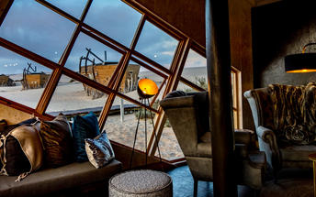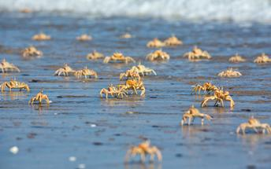

Basis
Fully Inclusive - Bed, All Meals, Fees and Activities
All Drinks (excl Premium Brands) Included

Day 5-7: Onguma The Fort, Etosha East

Etosha East
On the eastern edge of Etosha National Park, the park itself is bordered by numerous private reserves and access into the park is via the Von Lindequist Gate, named after Dr. Friedrich von Lindequist who proclaimed it a game reserve in March 1907. This side of the park is characterised by flat endless plains, tree-savanna type of vegetation and fantastic waterholes, where you could easily spot any of the prolific wildlife Etosha is known for. There's an abundance of wildlife here.

Day Itinerary
Flight: Möwe Bay – Ondangwa 1 hour & 25 minutes – refuel (30 minutes)
Ondangwa - Etosha 30 minutes
- Road transfer to airstrip for departure flight
- Private charter flight from Möwe Bay to Ondangwa to refuel and then on to Etosha National Park (east)
- Road transfer to the lodge on arrival
- Includes: All meals, Etosha AM drive & Onguma Sundowner drive (daily), park fees & local branded drinks
- Etosha is one of Africa's great game parks. With 114 species of mammal and 340 species of birds you are sure to see a great variety of wildlife on your safari

Overnight: Onguma The Fort View iBrochure
With a range of desert-adapted architectural styles, The Fort in Onguma Game Reserve is an award-winning Namibian Safari Lodge near Etosha National Park.
The Fort at Onguma was refurbished and re-launched in 2008 to instant international acclaim. Taking the safari brief to the edge of conception, South African architects Slee incorporated natural materials and dramatic simplicity to create one of the most striking safari lodges in Namibia.
Walls are untreated and partially clad in stone, the interiors are uncluttered and furnished with great care and all about are vast windows and doors that frame the wilderness and invite the cool air inside.
Attention to detail goes way beyond sublime décor and remarkable design. Moroccan meets classical African safari. The service and standards match international levels and the food, wine, staff and management as one complement the arresting grandeur of The Fort at Onguma.And yet, not despite but perhaps because of the exceptional safari lodge and accommodation, the game viewing and wilderness experience remains the leading lady of this magnificent show.
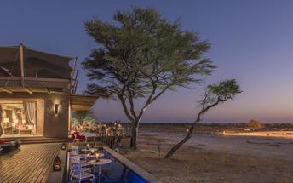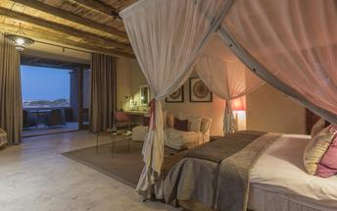

Basis
Fully Inclusive - Bed, All Meals, Fees and Activities
All Drinks (excl Premium Brands) Included

Day 7: End of Itinerary

Day Itinerary
Flight: Etosha – Windhoek 1 hour & 40 minutes
  - After your morning activity as included, you will road transfer to the airstrip for your departure flight.
  - Private charter flight from Etosha to Windhoek International Airport. Keeping in mind that you need to be at the airport 2 hours prior to your international departure flight time.
  - End of services

Basis
Bed and Breakfast

Transport

Flight Information
Date | Flight | Airline | Departure Airport | Time | Arrival Airport | Time | Class | Ref
 | Charter Flight |  | Hosea Kutako International Airport [WDH] |  | Sossusvlei Airstrip
 | Charter Flight |  | Sossusvlei Airstrip |  | Swakopmund Airport [SWP]
 | Charter Flight |  | Swakopmund Airport [SWP] |  | Mowe Bay Airstrip
 | Charter Flight |  | Mowe Bay Airstrip |  | Ondangwa Airport [OND]
 | Charter Flight |  | Ondangwa Airport [OND] |  | Mokuti Lodge Airport [OKU]
 | Charter Flight |  | Mokuti Lodge Airport [OKU] |  | Hosea Kutako International Airport [WDH]

Transfers
Date | Company | Pick Up | Drop Off | Time | Vehicle
 |  | Sossusvlei Airstrip | Hoodia Desert Lodge |  | Fully Guided Trip
 |  | Hoodia Desert Lodge | Sossusvlei Airstrip |  | Fully Guided Trip
 |  | Mowe Bay Airstrip | Shipwreck Lodge |  | Fully Guided Trip
 |  | Shipwreck Lodge | Mowe Bay Airstrip |  | Fully Guided Trip
 |  | Mokuti Lodge Airport [OKU] | Onguma The Fort |  | Fully Guided Trip
 |  | Onguma The Fort | Mokuti Lodge Airport [OKU] |  | Fully Guided Trip

Terms and Conditions

Africa Travel Tours Terms and Conditions
Contract
1.1 The contract will become effective as from the date the invoice is completed and the deposit, referred to in Clause 2.1, is received by Africa Tours & Safaris CC (hereinafter known as the Company).
1.2 The contract is subject to the Namibian Law.
1.3 Any person making a reservation as per Clause 8.4 accepts the terms and conditions of this agreement set out hereunder.
How to Book
2.1 A 20% deposit of the full amount due is required to confirm any reservation and is to be done by the agent or client (see Clause 8.1) in writing or by e-mail.
2.2 The Company must receive the balance of the contract price no later than 42 days (6 weeks) prior to departure.
2.3 If the Company does not receive the full contract price 42 days (6 weeks) before the departure date, the Company may cancel the reservation and retain whatever deposit or other funds it has already received from the client or his agent.
How to Pay
3 The payment options will be provided upon confirmation of a booking.
Our Cancellation Policy
4.1 Any cancellation of a confirmed booking must be done in writing (email) to the Company whereupon cancellation charges as per Clause 4.2 will apply.
4.2 The following cancellation fees (as a percentage of the fully quoted price) are applicable to any cancelled travel:
Notice from date of travel: Cancellation fee:
42 days or more 20% (deposit forfeited)
29 – 41 days 50%
15 – 28 days 75%
0 – 14 days 100%
Please note: the notice period is calculated from the date of cancellation to the start date of the tour/safari booking.
4.3 No refund will be made by the Company if, for any reason, inclusions or parts of the tour cannot be carried out / or utilised. These would include all facets such as meals, game drives, accommodation etc. This would also apply to any client who has booked a tour but fails to undertake the tour for any reason.
Our Changes Policy
5 If a booking is changed to an earlier date than originally reserved, the Company will endeavour to change it. If the booking is for a later date, charges as per Clause 4.2 could apply.
As things go, we've all had to adapt to changes during the Coronavirus pandemic and so too have we therefore amended our terms and conditions for travel during such times. Check out the Updated COVID Terms and Conditions here.
Price Changes
6.1 The Company reserves the right to increase the price of any tour prior to departure due to factors beyond the control of the Company, such as, without being limited to, and increase in fuel prices, new Government legislation, accommodation price increases, fluctuations in exchange rates, etc.
6.2 If the Company announces an in increase in the tour price in terms of this Clause, such addition amount must be paid to the Company before the departure of such tour or else the Company shall have the right to cancel the tour and the charges in Clause 4.2 will apply.
Changes to Itineraries
7 The Company shall at any time have the right, in its entire discretion, to alter the terms of the booking in relation to the route, timetable, itinerary and accommodation. The Company shall, however, make every effort to offer the client an alternative tour of a comparable standard.
Should the alternative be of a lesser standard, the client will be refunded the difference, but should there be an increase, the client shall have the right to either reject the alternative and obtain a refund of the relevant portion of the original contract sum, or to accept the alternative and pay the increased cost. In the event of the client rejecting the alternative tour and claiming a refund, such rejection will be treated as a cancellation and the refund will be calculated according to Clause 4.2 hereof. The client shall have no claim against the Company for any damages arising out of the alternative booking.
Responsibility and Liability
8.1 Neither the Company nor any person acting for through and on behalf of the Company shall be liable for any loss or damage whatsoever arising from any cause whatsoever and without restricting the generality of the aforegoing shall particularly not be responsible for the loss or damage arising from any errors or omissions contained in its brochure or other literature, late or non-confirmation or acceptance or bookings, loss or damage caused by delays, sickness, injury or death, whether occasioned by negligence or not.
8.2 The Company shall have the right at any time at is sole discretion, to cancel or the remainder thereof or to make an alteration in the route, accommodation price or other details. This would include any event of any tour being rendered impossible, illegal, or inadvisable by weather, avalanches, strike, war, government or other interference or due to any other cause whatsoever. The extra expenses incurred as a result thereof shall be the responsibility of the client.
8.3 The Company may at its discretion and without liability or cost to itself at any time cancel, or terminate, a client's booking and in particular, without limiting the generality of the foregoing, it shall be entitled to do so in the event of illness or the illegal or incompatible behaviour of any client undertaking the tour, who shall in such circumstances not be entitled to any refund.
8.4 Any person making a reservation with the Company (refer to Clause 1.1) warrants that her or she has the necessary authority to enter into this contract on behalf of the person or persons included in such a booking. The person making the reservation shall be liable for the total amount due to the Company.
Client's Obligations
9.1 It is the onus and responsibility of the client to obtain the necessary comprehensive insurance before departure for any possible cancellations, medical expenses, protection or personal property and money.
9.2 The onus is upon the client to ensure that passports and visas are valid for the duration of the safari. The Company cannot be held liable for any necessary visas or other travel documents not held by clients. In the event of a client not having the necessary documentation to enter any area or country the Company shall reserve the right to leave the client a the point of entry of such area or country. In such an event, the Company will not be held responsible to the client for further travel arrangements.
9.3 The onus is upon the client to ensure that the SARS-CoV-2 PCR tests are done prior to commencement of the safari and valid on arrival in accordance to the requirements of the country of intended travel and for the airline with which the client will travel. The same applies for any necessary testing for departure. The costs of any such COVID testing will be for the clients own account. While The Company can assist with arrangements for testing in-country, The Company will not be held responsible to the client for such arrangements and with regards to return time of test results.
9.4 Should the client need to undergo mandatory quarantine once in-country with regards to the SARS-CoV-2 virus, either on arrival as called for by the authorities or due to testing positive once in-country, this will be at the clients own expense.
Health and Personal Safety
10.1 The client shall be reasonably fit to undertake the tour.
10.2 Anti-malaria precautions should be commenced prior to tour departure. A medical doctor should be consulted for advice.
10.3 Tours offered by the Company cover a wide spectrum of the African wilds and neither the Company, its employees or agents can be held responsible for any injury or other related incidents whilst on the tour / safari.
10.4 The Company cannot be held responsible for any client who falls ill or contracts the SARS-CoV-2 virus while in-country. The client accepts that travel is at own risk.
Baggage
11.1 Clients are limited to one soft sports type bag per person with a maximum weight of 20 kilograms. This includes photographic equipment and hand luggage.
11.2 Due to the rugged terrain, the Company cannot be held responsible for damage or loss of any personal items including bags, contents of bags or photographic and related equipment. Due to extremely dusty conditions, please ensure all bags are dust proof.
Airline and Car Hire Clause
12.1 The Company will act as the agent of the client when booking the client with a car hire company, an airline or air charter service. The client therefore contracts with the car hire company, airline or charter service and not with the Company.
12.2 Charter flights are normally operated by smaller type aircraft such as Cessna 210. Luggage is strictly limited to 10-15 kgs (depending on terms of particular airline used) per person in soft hold all type bags. Due to the desert heat, it is not safe to overload aircraft thus this limit needs to be strictly controlled.
Travelling or thinking of travelling during the COVID-19 pandemic? Take a look at our COVID Terms and Conditions for more information on how this will work and differ from our standard terms and conditions as listed above.

